Piecewise Path
# Source: AI Source: Provided by: [Data Path: Persons Table -> ID Column: 1, Name_En Column: Motasem Essam] -> From: [ChatGPT] on [7/25/2026]
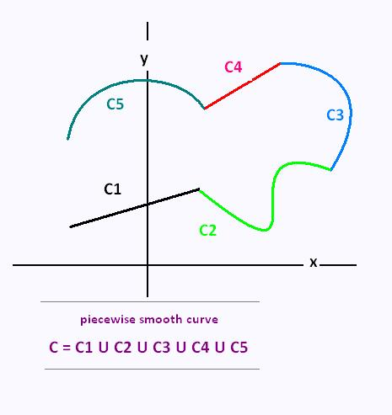
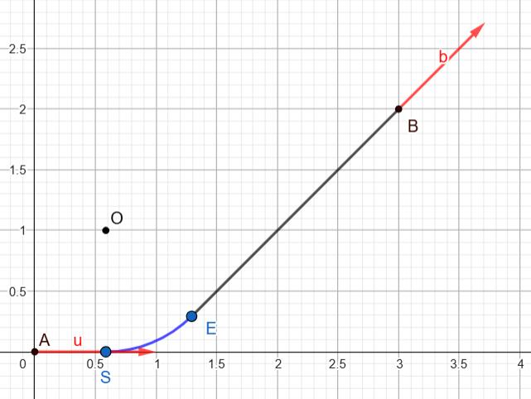
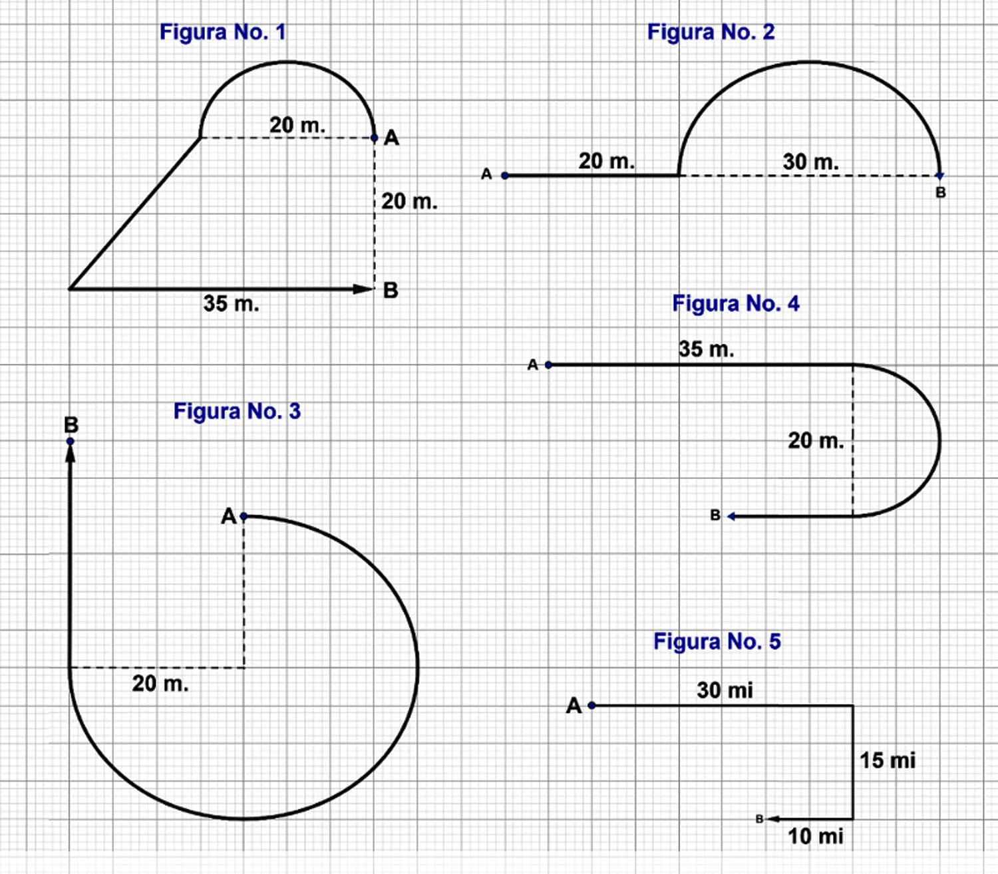
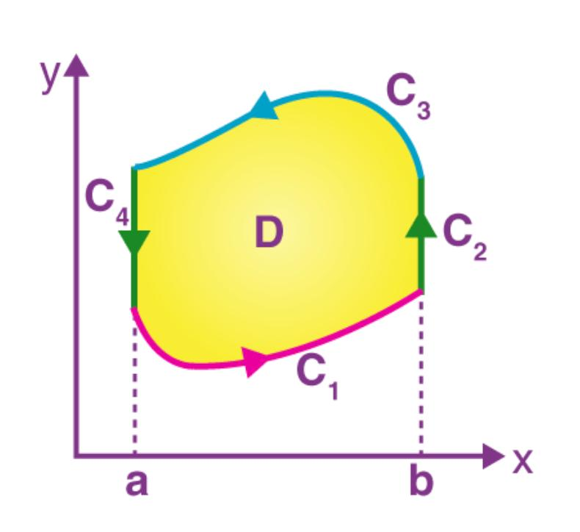

Definition
# Source: AI Source: Provided by: [Data Path: Persons Table -> ID Column: 1, Name_En Column: Motasem Essam] -> From: [ChatGPT] on [7/25/2026]
A Piecewise Path is a geometric path composed of two or more connected pieces, where each piece may follow its own geometric rule.
The pieces may be:
- straight-line segments
- circular arcs
- parabolic arcs
- elliptical arcs
- other curves
- or combinations of different path types.
If a path consists of $n$pieces, it can be represented as:
$$\boxed{P=P_{1}∪P_{2}∪⋯∪P_{n}}$$
where each $P_{i}$represents one portion of the complete path.

Simple Definition
# Source: AI Source: Provided by: [Data Path: Persons Table -> ID Column: 1, Name_En Column: Motasem Essam] -> From: [ChatGPT] on [7/25/2026]
A Piecewise Path is a path made from several connected pieces, where different pieces may have different geometric forms.
For example:
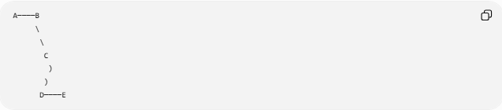
A────B
\
\
C
)
)
D────E
This could consist of:
$$\boxed{\text{Straight Segment}→\text{Straight Segment}→\text{Circular Arc}→\text{Straight Segment}}$$

Main Classification
# Source: AI Source: Provided by: [Data Path: Persons Table -> ID Column: 1, Name_En Column: Motasem Essam] -> From: [ChatGPT] on [7/25/2026]
A practical classification of Piecewise Paths is:
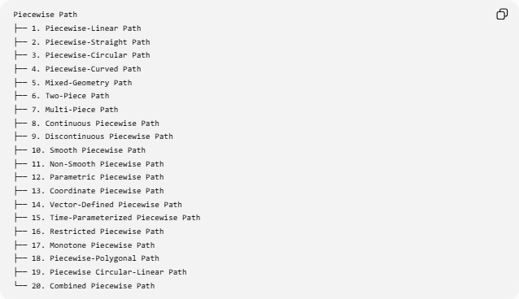
Piecewise Path
├── 1. Piecewise-Linear Path
├── 2. Piecewise-Straight Path
├── 3. Piecewise-Circular Path
├── 4. Piecewise-Curved Path
├── 5. Mixed-Geometry Path
├── 6. Two-Piece Path
├── 7. Multi-Piece Path
├── 8. Continuous Piecewise Path
├── 9. Discontinuous Piecewise Path
├── 10. Smooth Piecewise Path
├── 11. Non-Smooth Piecewise Path
├── 12. Parametric Piecewise Path
├── 13. Coordinate Piecewise Path
├── 14. Vector-Defined Piecewise Path
├── 15. Time-Parameterized Piecewise Path
├── 16. Restricted Piecewise Path
├── 17. Monotone Piecewise Path
├── 18. Piecewise-Polygonal Path
├── 19. Piecewise Circular-Linear Path
└── 20. Combined Piecewise Path
Note: This is a practical classification rather than a single universally standardized taxonomy. Some categories describe the geometry of the pieces, while others describe the number of pieces, continuity, representation, or constraints.

1. Piecewise-Linear Path
# Source: AI Source: Provided by: [Data Path: Persons Table -> ID Column: 1, Name_En Column: Motasem Essam] -> From: [ChatGPT] on [7/25/2026]
Definition
A Piecewise-Linear Path is a path consisting entirely of straight-line pieces.
$$\boxed{P=P_{1}∪P_{2}∪⋯∪P_{n}}$$
where every $P_{i}$is a line segment.
Example
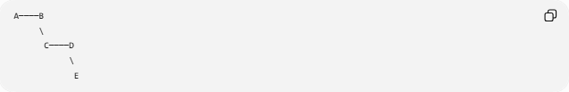
A────B
\
C────D
\
E
Every piece is straight.
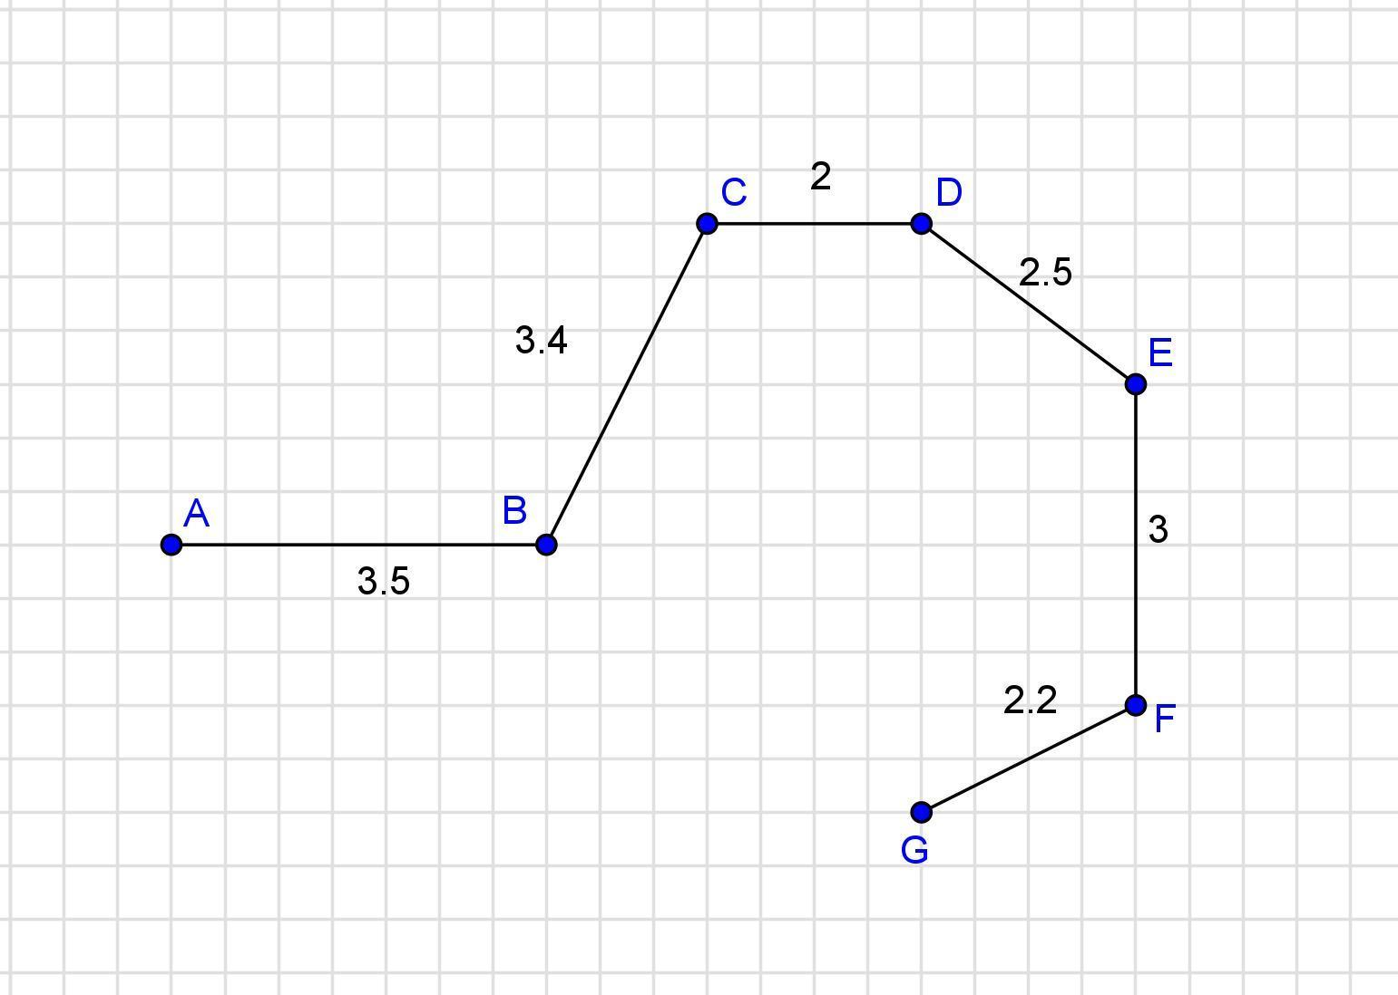
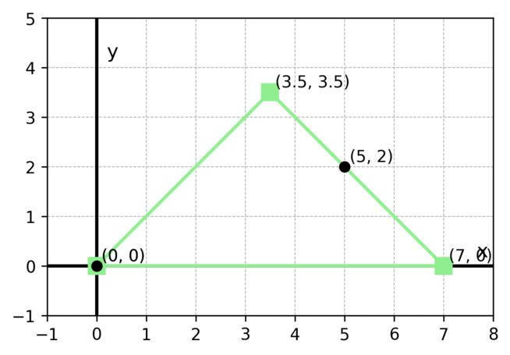
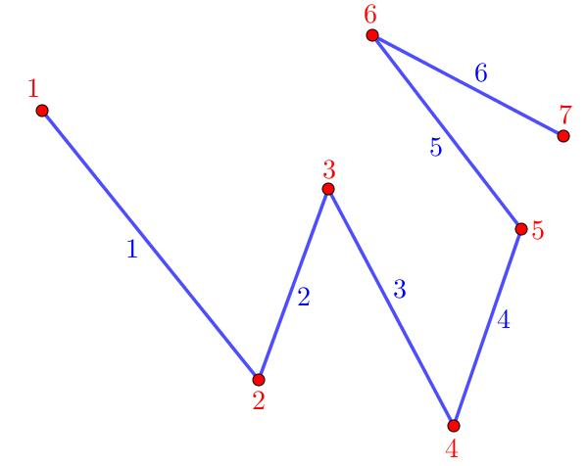
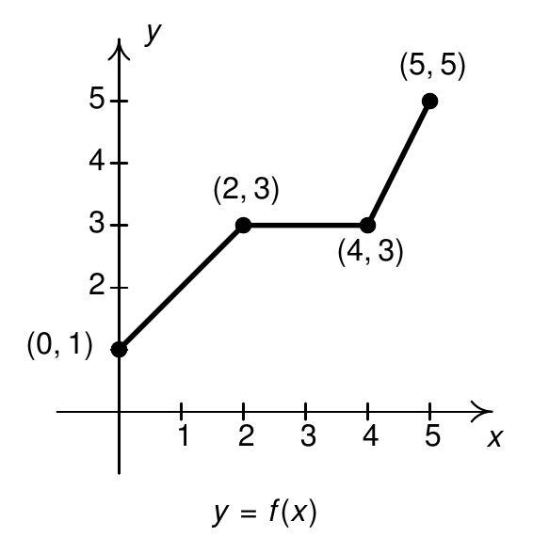
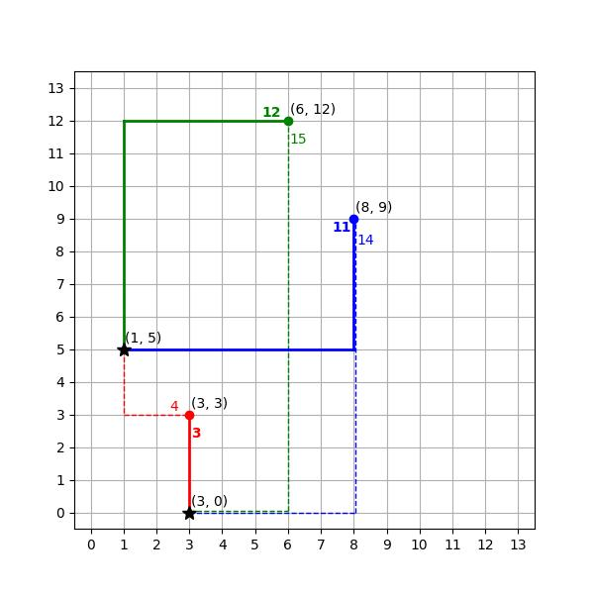
Important Relationship
In the usual geometric sense:
$$\boxed{\text{Polygonal Path}=\text{Piecewise-Linear Path}}$$
Thus, a polygonal path is the principal geometric example of a piecewise-linear path.

2. Piecewise-Straight Path
# Source: AI Source: Provided by: [Data Path: Persons Table -> ID Column: 1, Name_En Column: Motasem Essam] -> From: [ChatGPT] on [7/25/2026]
Definition
A Piecewise-Straight Path consists of multiple straight-line segments connected at vertices.
Example
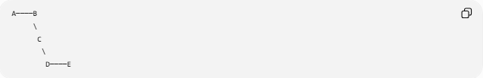
A────B
\
C
\
D────E
Each portion is a straight-line path.
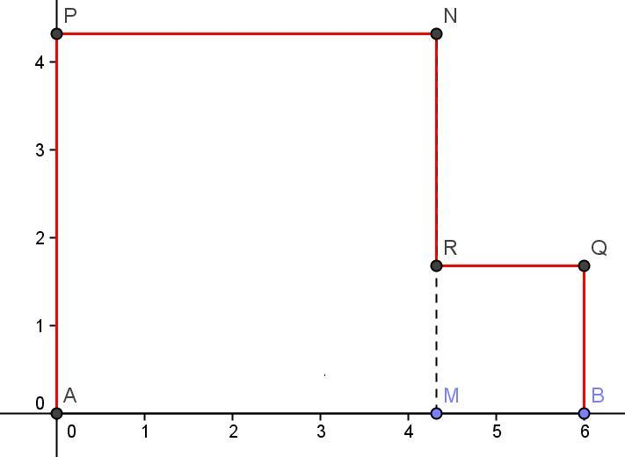
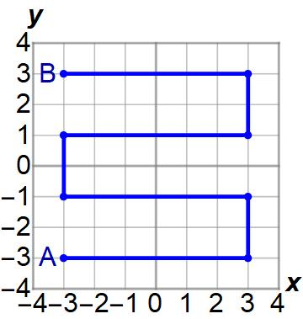
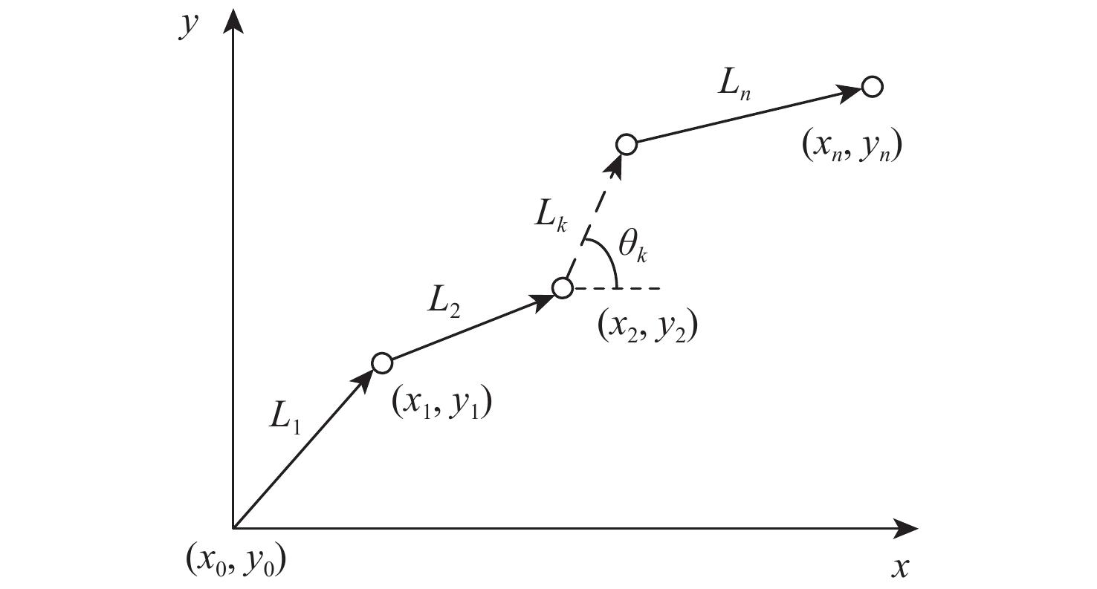
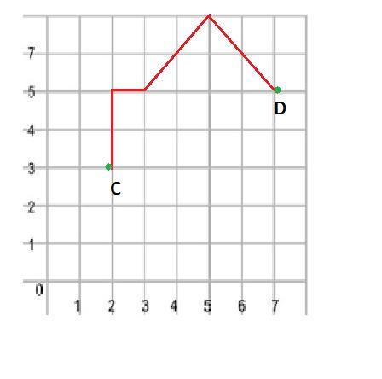
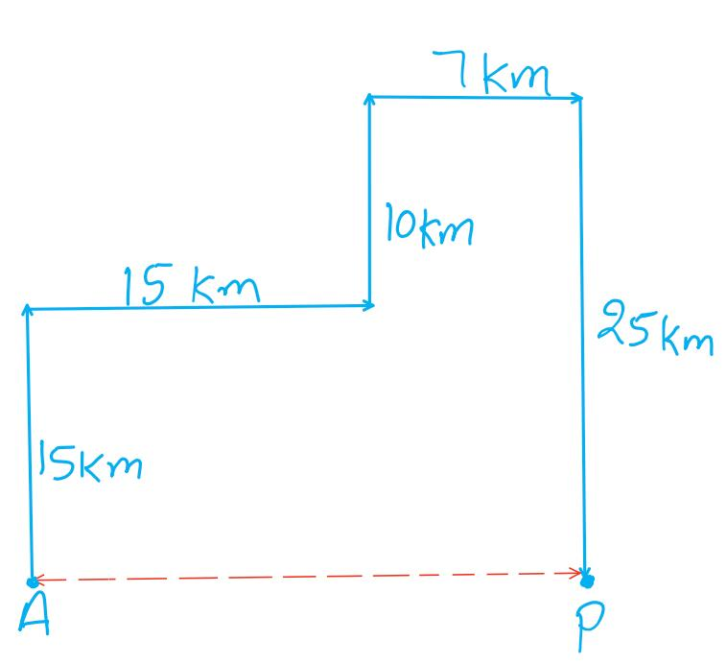
Relationship
A piecewise-straight path is essentially a polygonal path when the pieces are finite line segments.

3. Piecewise-Circular Path
# Source: AI Source: Provided by: [Data Path: Persons Table -> ID Column: 1, Name_En Column: Motasem Essam] -> From: [ChatGPT] on [7/25/2026]
Definition
A Piecewise-Circular Path consists of multiple circular arcs.
Different pieces may belong to circles with different:
- centers
- radii
- angular intervals.
Example
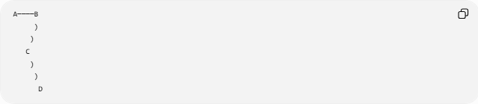
A────B
)
)
C
)
)
D
Each curved portion lies on a circle.
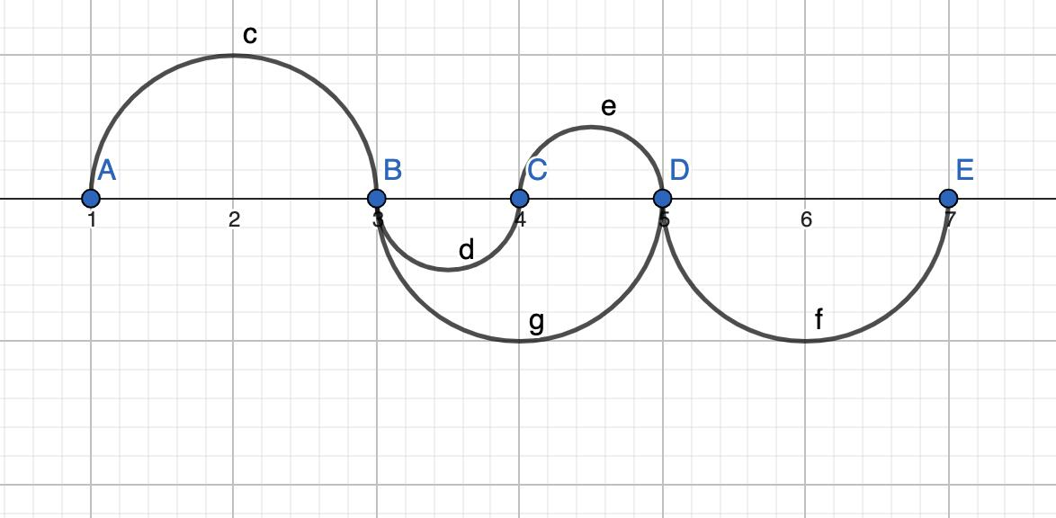
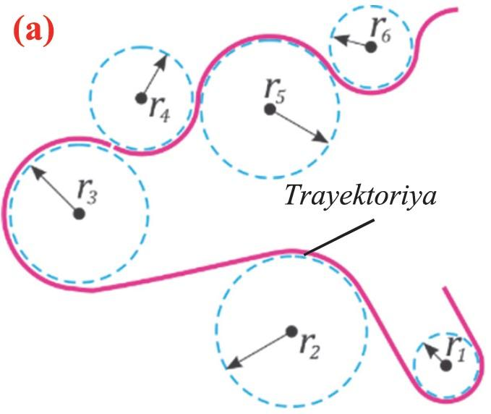
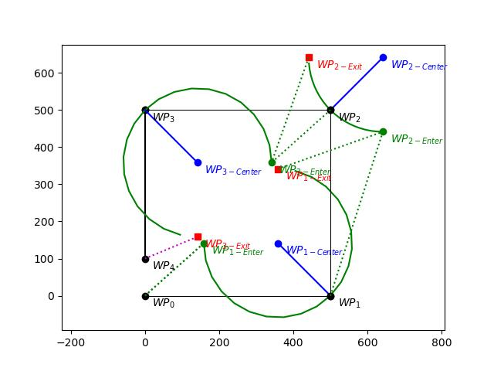
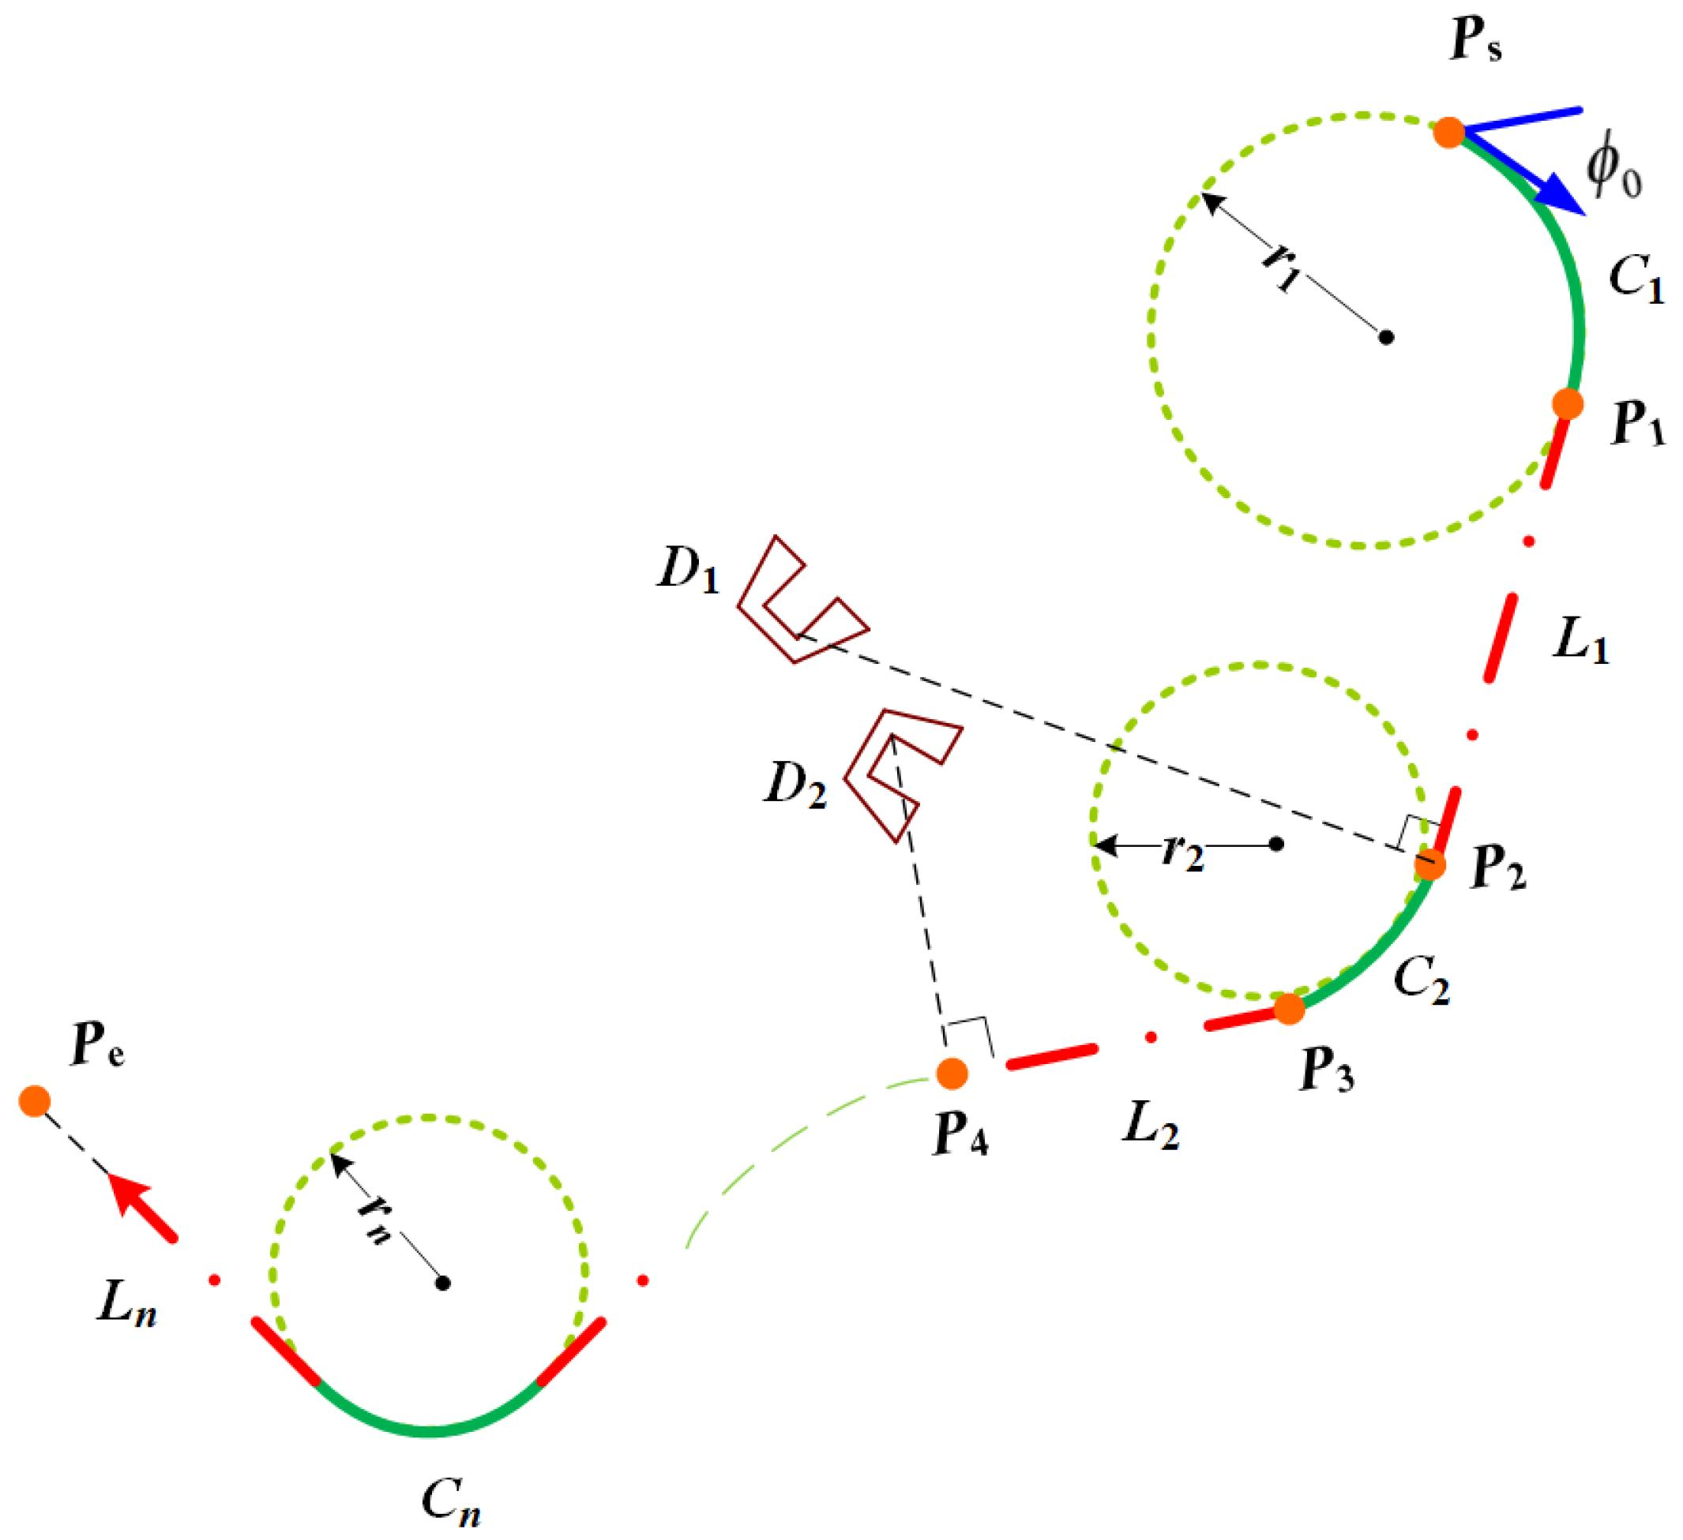
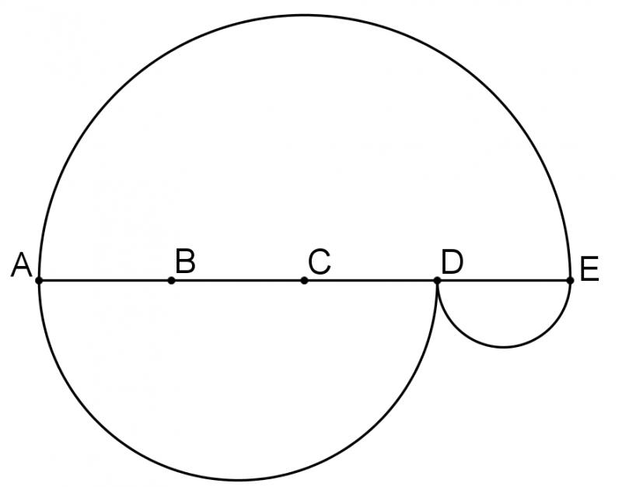
For a circular piece:
$${\left(x-h\right)}^{2}+{\left(y-k\right)}^{2}=r^{2}.$$

4. Piecewise-Curved Path
# Source: AI Source: Provided by: [Data Path: Persons Table -> ID Column: 1, Name_En Column: Motasem Essam] -> From: [ChatGPT] on [7/25/2026]
Definition
A Piecewise-Curved Path consists of several curved pieces. The pieces do not necessarily belong to the same family of curves.
For example:
$$\boxed{\text{Circular Arc}→\text{Parabolic Arc}→\text{Elliptical Arc}}$$
Example
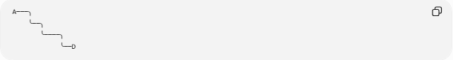
A───╮
╰──╮
╰────╮
╰──D
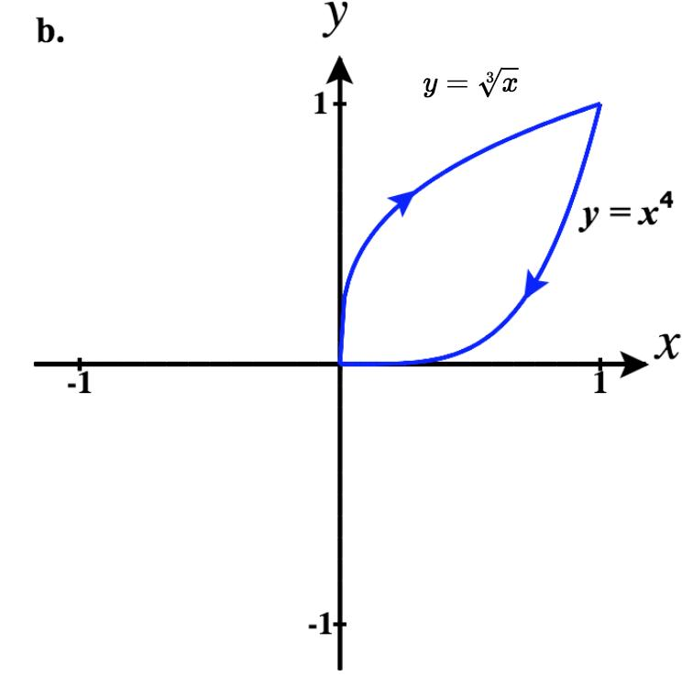
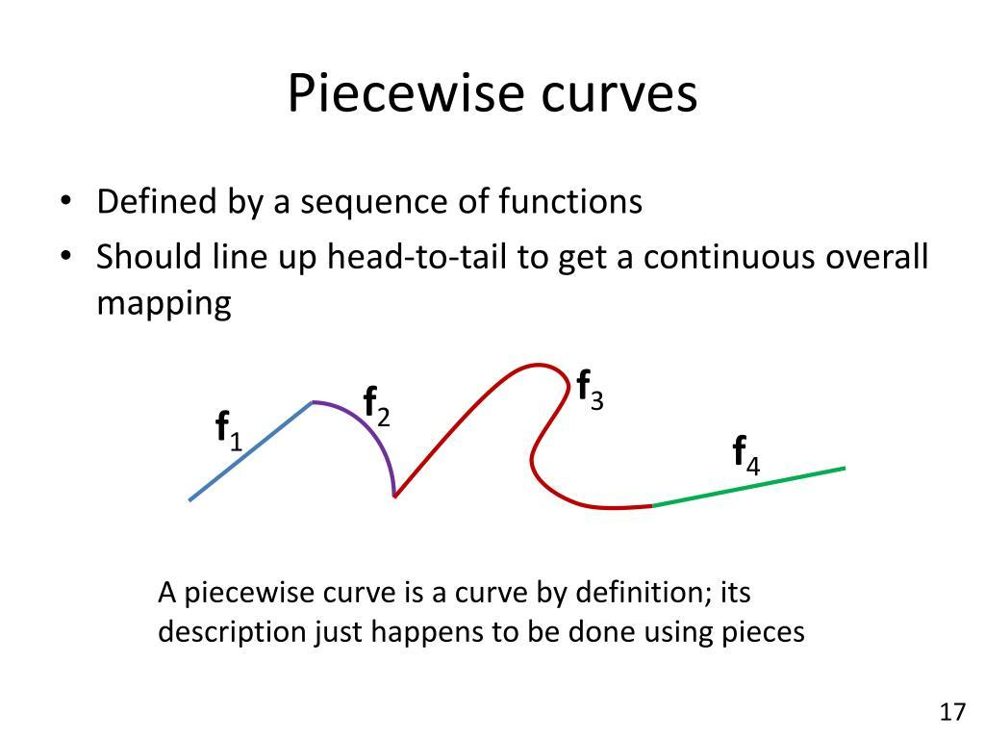
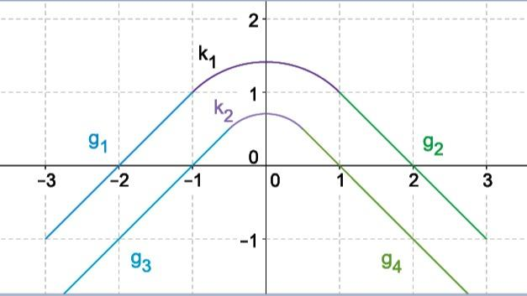

5. Mixed-Geometry Path
# Source: AI Source: Provided by: [Data Path: Persons Table -> ID Column: 1, Name_En Column: Motasem Essam] -> From: [ChatGPT] on [7/25/2026]
Definition
A Mixed-Geometry Path combines different geometric path types.
For example:
$$\boxed{\text{Straight}→\text{Circular}→\text{Straight}}$$
Example
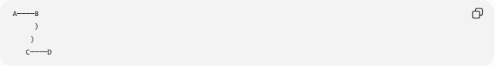
A────B
)
)
C────D
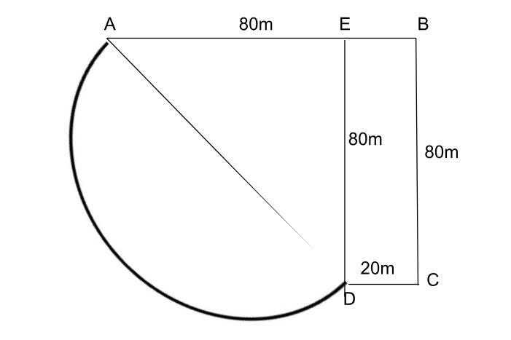
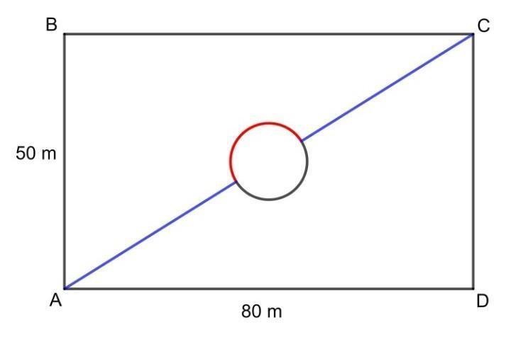
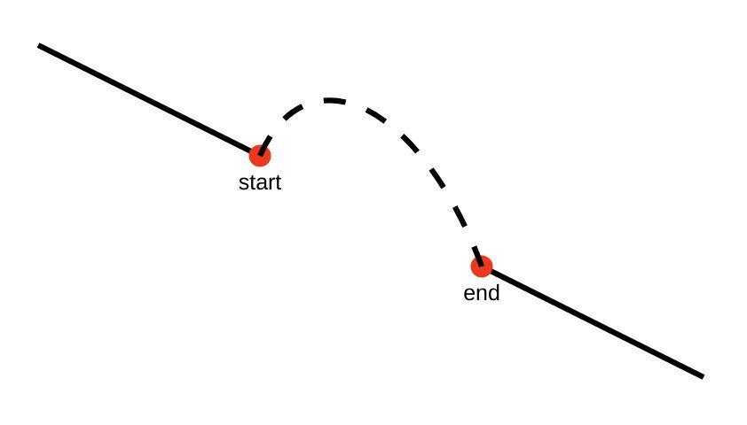
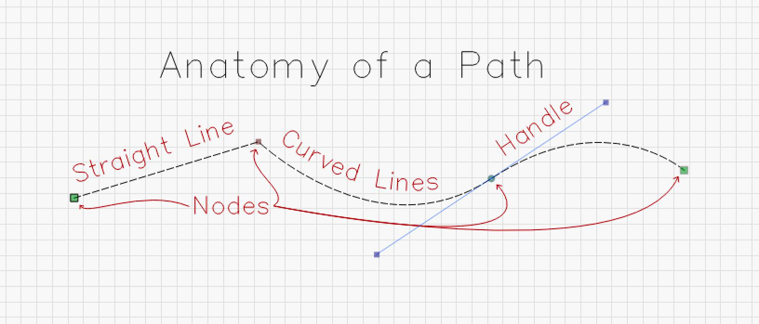
This is particularly useful for representing realistic routes.

6. Two-Piece Path
# Source: AI Source: Provided by: [Data Path: Persons Table -> ID Column: 1, Name_En Column: Motasem Essam] -> From: [ChatGPT] on [7/25/2026]
Definition
A Two-Piece Path consists of exactly two path pieces.
$$\boxed{P=P_{1}∪P_{2}}$$
Example
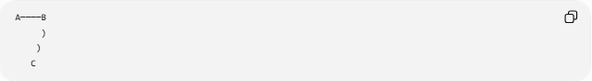
A────B
)
)
C
The path contains:
- a straight segment
- a circular arc.
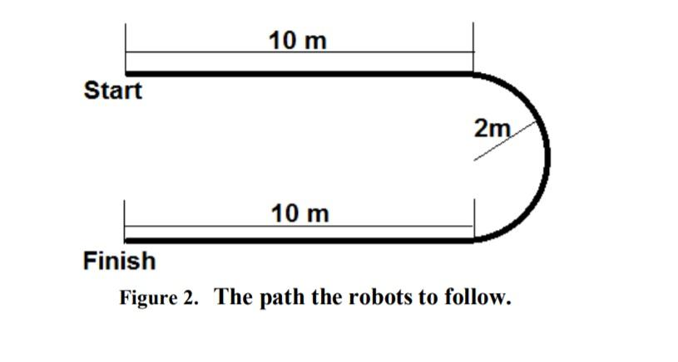
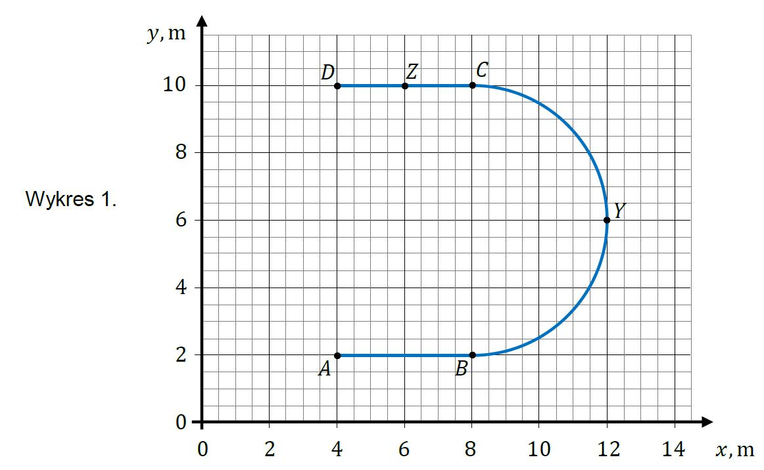

7. Multi-Piece Path
# Source: AI Source: Provided by: [Data Path: Persons Table -> ID Column: 1, Name_En Column: Motasem Essam] -> From: [ChatGPT] on [7/25/2026]
Definition
A Multi-Piece Path consists of three or more path pieces.
$$\boxed{P=P_{1}∪P_{2}∪⋯∪P_{n}, n≥3}$$
Example
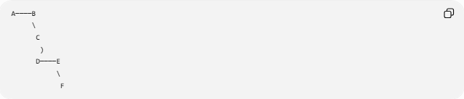
A────B
\
C
)
D────E
\
F
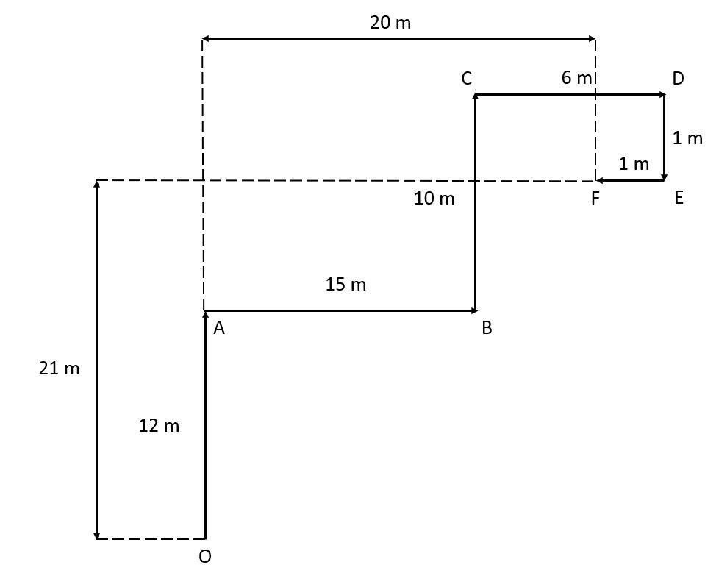
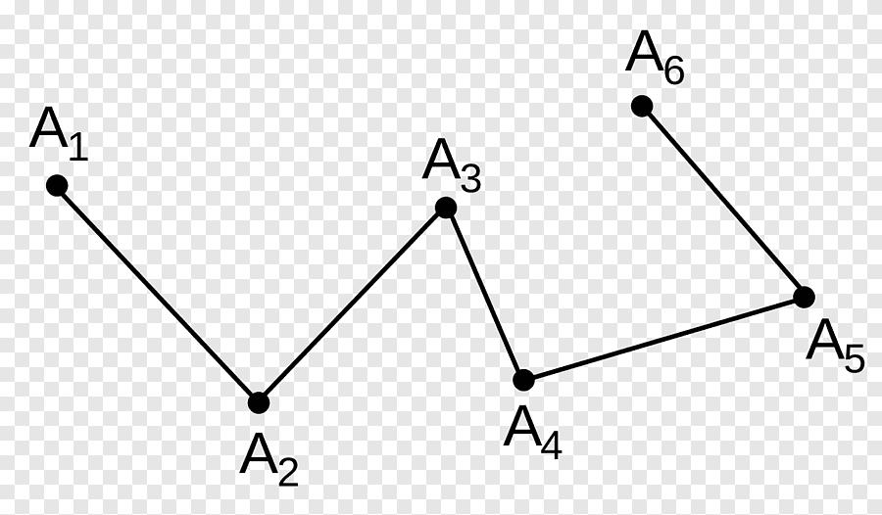
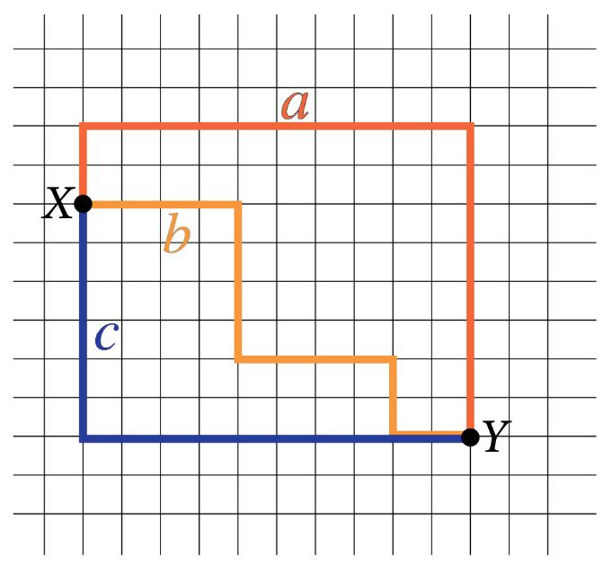
The pieces may all have the same type or may have different types.

8. Continuous Piecewise Path
# Source: AI Source: Provided by: [Data Path: Persons Table -> ID Column: 1, Name_En Column: Motasem Essam] -> From: [ChatGPT] on [7/25/2026]
Definition
A Continuous Piecewise Path is a piecewise path whose consecutive pieces connect without gaps.
At a junction $V$:
$$\boxed{P_{i}\left(t_{0}\right)=P_{i+1}\left(t_{0}\right)}$$
Example
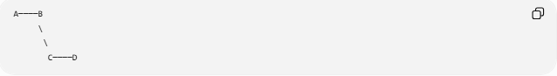
A────B
\
\
C────D
The path reaches $B$and immediately continues into the next piece.
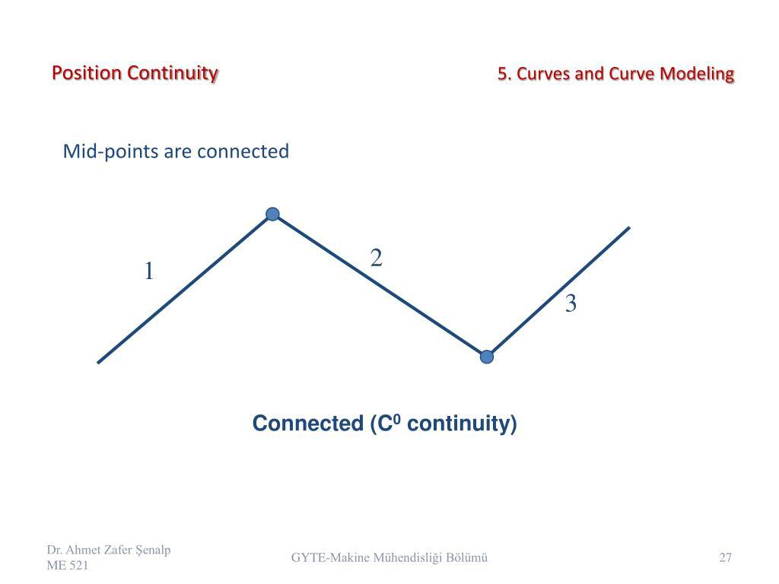
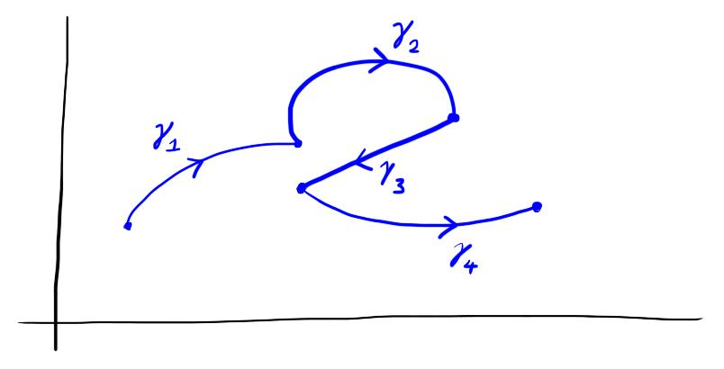
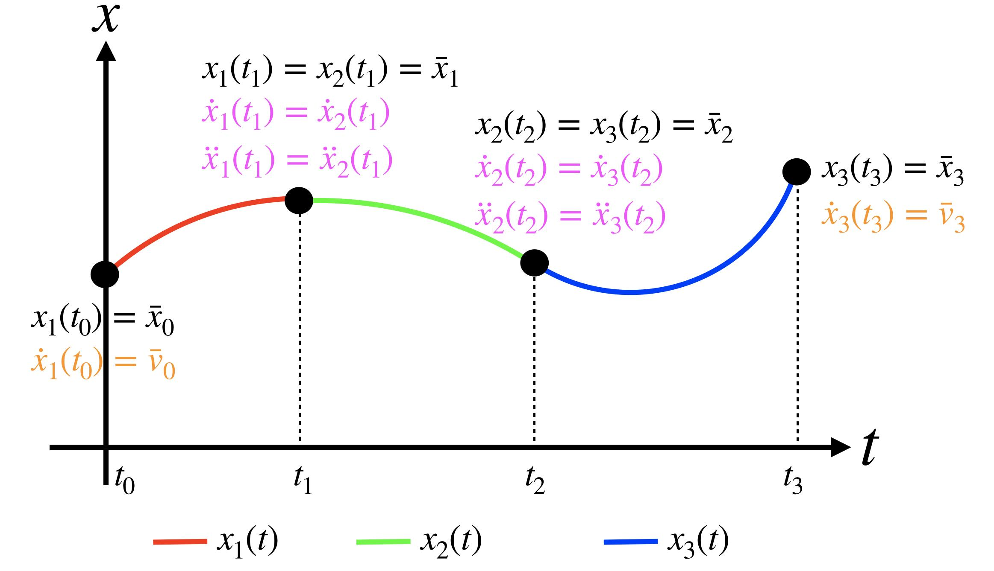
Important
Continuity means the position connects.
It does not necessarily mean that the direction is smooth.

9. Discontinuous Piecewise Path
# Source: AI Source: Provided by: [Data Path: Persons Table -> ID Column: 1, Name_En Column: Motasem Essam] -> From: [ChatGPT] on [7/25/2026]
Definition
A Discontinuous Piecewise Path contains a break or jump between pieces.
Example
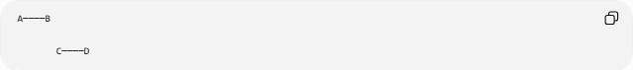
A────B

C────D
There is a gap between $B$and $C$.
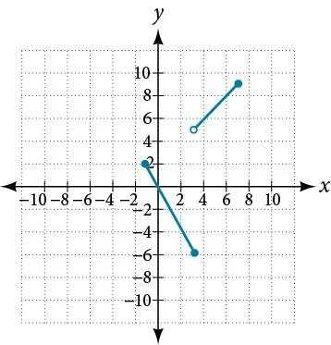
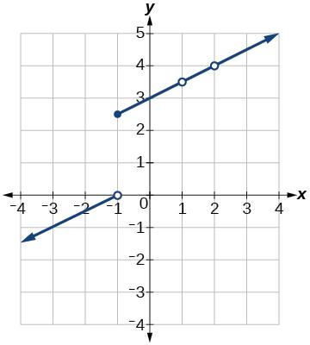
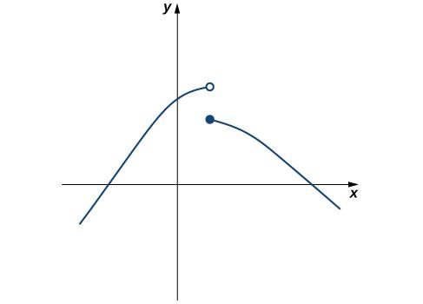
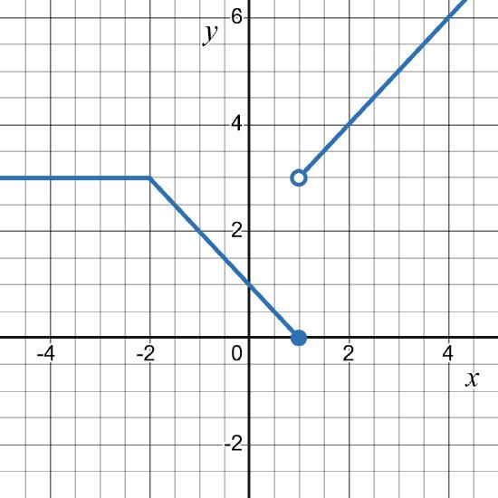
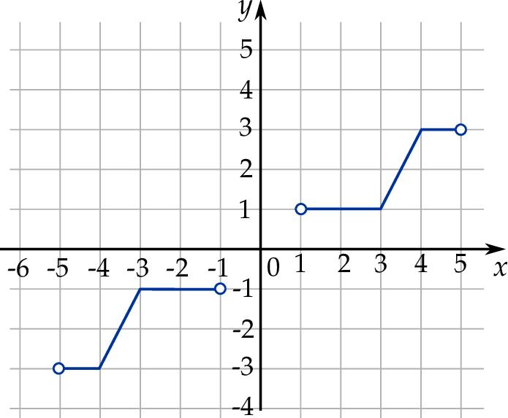
Mathematically, at a transition parameter $t_{0}$:
$$\boxed{\lim_{t→t_{0}^{-}}P\left(t\right)≠\lim_{t→t_{0}^{+}}P\left(t\right)}$$
A discontinuous collection of pieces is not one continuous traversal unless a jump is explicitly part of the model.

10. Smooth Piecewise Path
# Source: AI Source: Provided by: [Data Path: Persons Table -> ID Column: 1, Name_En Column: Motasem Essam] -> From: [ChatGPT] on [7/25/2026]
Definition
A Smooth Piecewise Path is a piecewise path whose consecutive pieces meet with matching tangent directions.
At a junction $V$:
$$\boxed{T_{1}\left(V\right)=T_{2}\left(V\right)}$$
Example
────╮
╰────
There is no sharp corner at the connection.
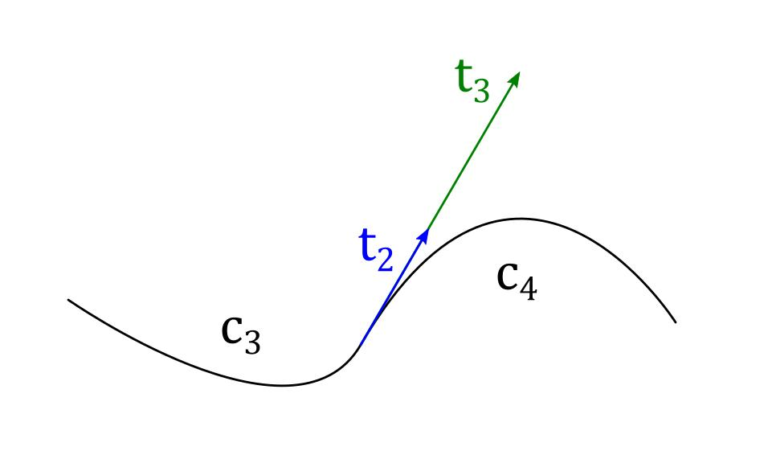
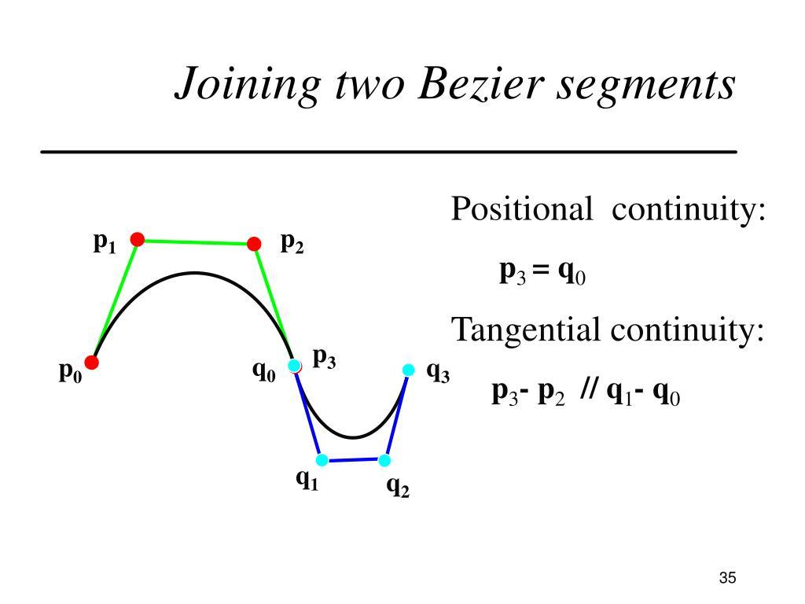
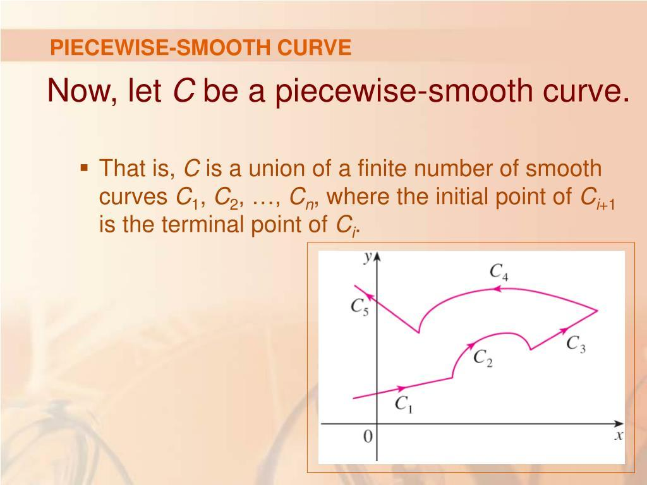
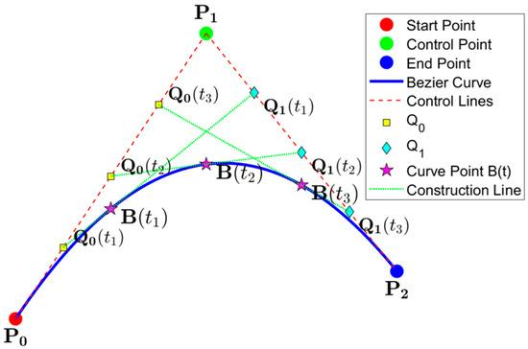
Important
A smooth path is continuous, but a continuous path does not have to be smooth.

11. Non-Smooth Piecewise Path
# Source: AI Source: Provided by: [Data Path: Persons Table -> ID Column: 1, Name_En Column: Motasem Essam] -> From: [ChatGPT] on [7/25/2026]
Definition
A Non-Smooth Piecewise Path is a path that may be continuous but has one or more sharp corners.
Example
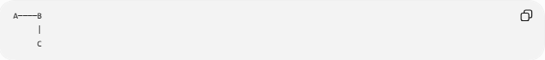
A────B
|
C
At $B$, the direction suddenly changes.
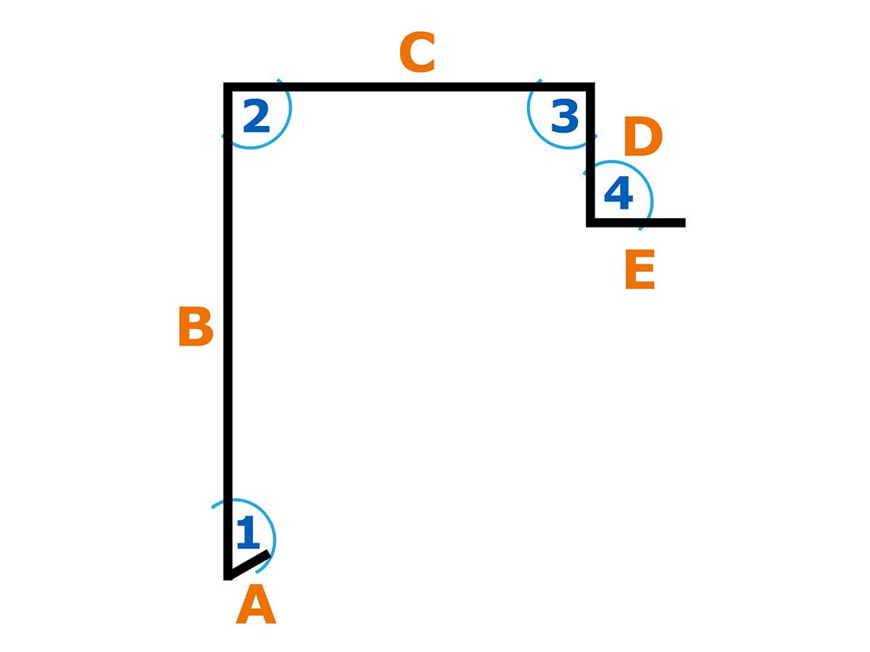
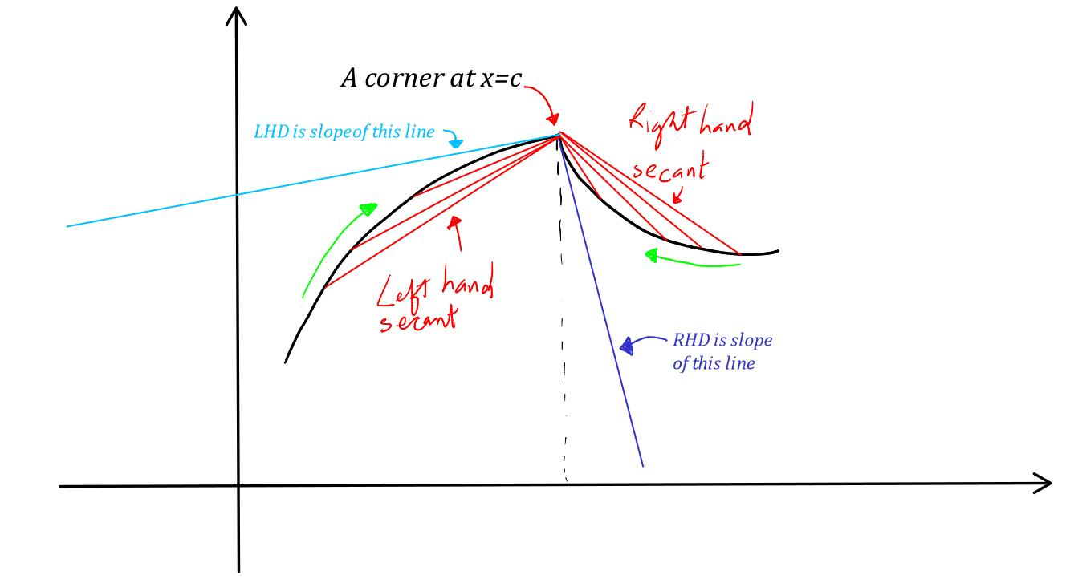
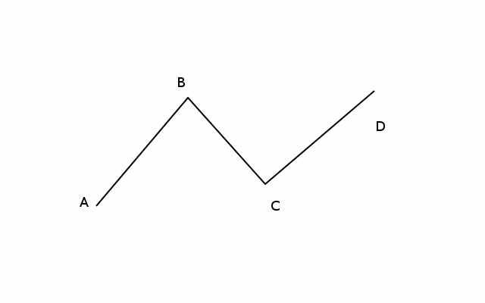
The position is continuous:
$$P\left(t_{0}^{-}\right)=P\left(t_{0}^{+}\right)$$
but generally:
$$\boxed{P^{'}\left(t_{0}^{-}\right)≠P^{'}\left(t_{0}^{+}\right)}$$

12. Parametric Piecewise Path
# Source: AI Source: Provided by: [Data Path: Persons Table -> ID Column: 1, Name_En Column: Motasem Essam] -> From: [ChatGPT] on [7/25/2026]
Definition
A Parametric Piecewise Path is represented by different parametric equations over different parameter intervals.
For example:
$$P\left(t\right)=\left\{\begin{matrix}\left(2 , t0\right), & 0≤t≤2, \\ \left(4 , 2t-4\right), & 2≤t≤4.\end{matrix}\right.$$
Example
This produces:
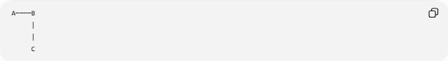
A────B
|
|
C
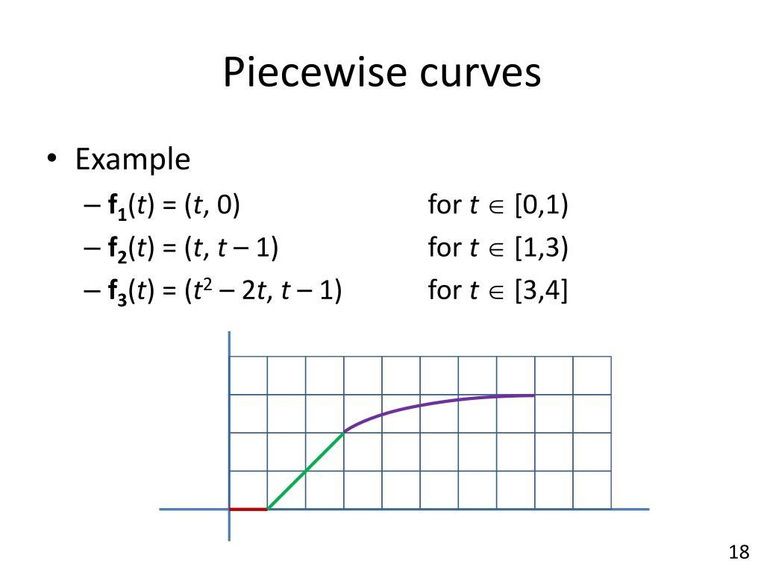
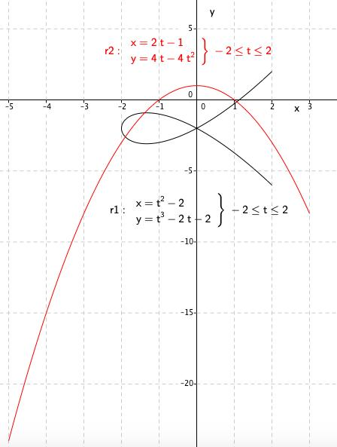
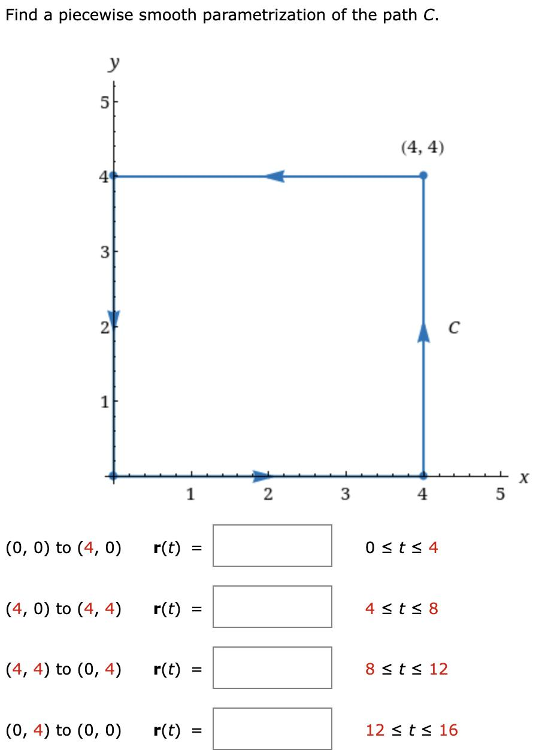
The first equation describes the horizontal portion and the second describes the vertical portion.

13. Coordinate Piecewise Path
# Source: AI Source: Provided by: [Data Path: Persons Table -> ID Column: 1, Name_En Column: Motasem Essam] -> From: [ChatGPT] on [7/25/2026]
Definition
A Coordinate Piecewise Path is defined by different coordinate equations on different portions of the domain.
Example
$$y=\left\{\begin{matrix}x, & 0≤x≤2, \\ 4-x, & 2≤x≤4.\end{matrix}\right.$$
This produces two line pieces.
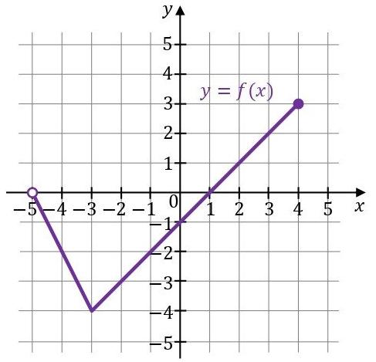
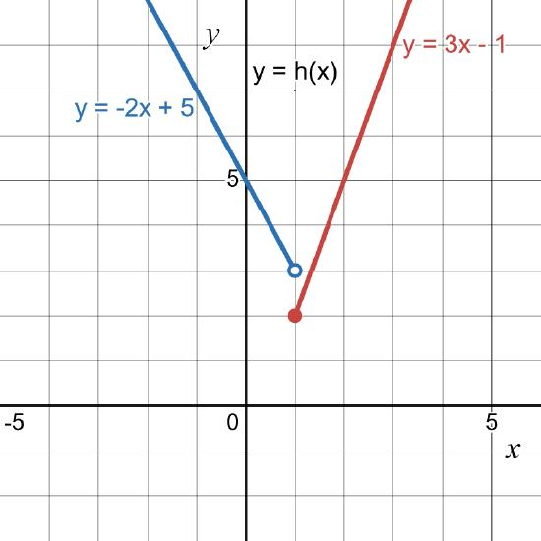
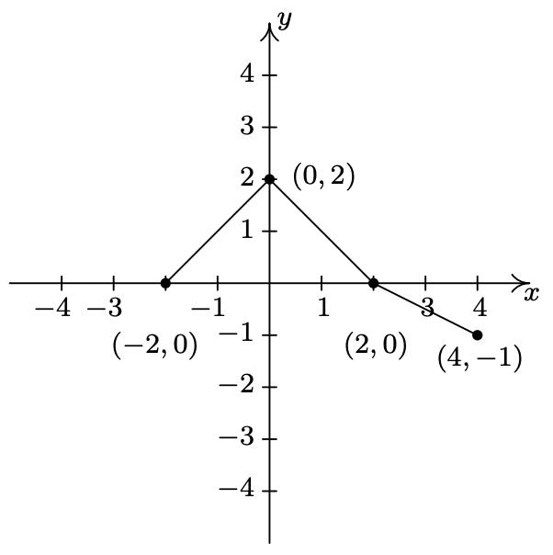
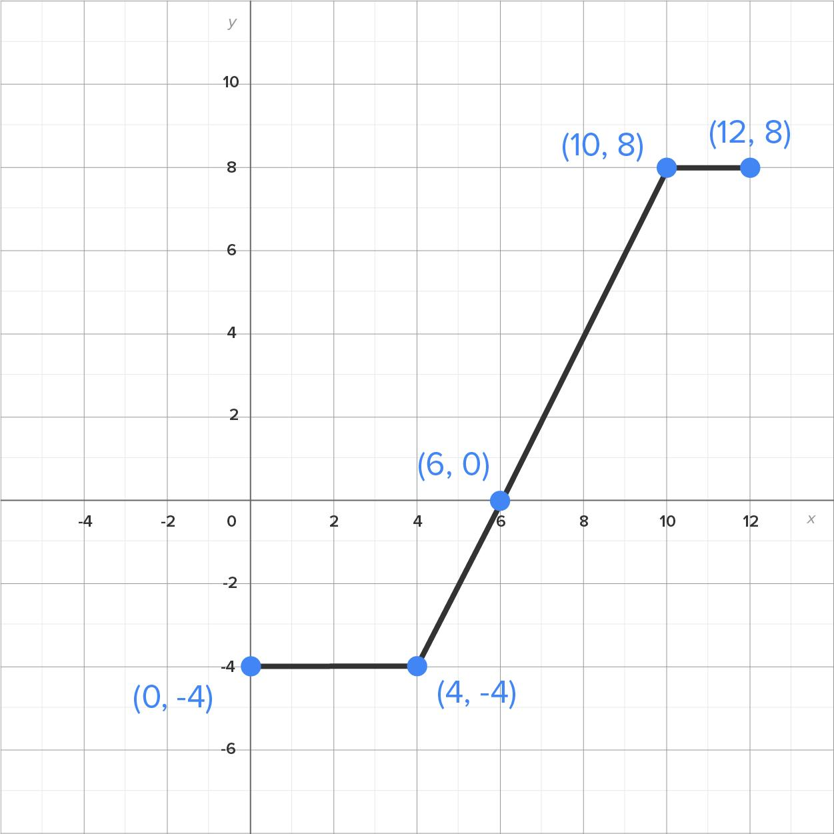
The pieces meet at:
$$\left(2 , 2\right).$$

14. Vector-Defined Piecewise Path
# Source: AI Source: Provided by: [Data Path: Persons Table -> ID Column: 1, Name_En Column: Motasem Essam] -> From: [ChatGPT] on [7/25/2026]
Definition
A Vector-Defined Piecewise Path represents each piece using a vector equation.
For a segment from $A$to $B$:
$$\boxed{r_{1}\left(t\right)=A+t\left(B-A\right)}$$
For the next segment:
$$\boxed{r_{2}\left(t\right)=B+t\left(C-B\right)}$$
Example
Let:
$$A=\left(0 , 0\right), B=\left(3 , 2\right), C=\left(6 , 0\right).$$
Then:
$$r_{1}\left(t\right)=\left(0 , 0\right)+t\left(3 , 2\right)$$
and:
$$r_{2}\left(t\right)=\left(3 , 2\right)+t\left(3 , -2\right).$$
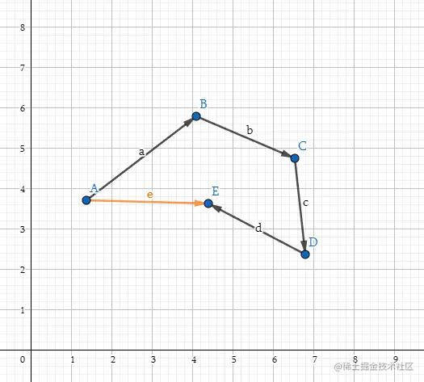
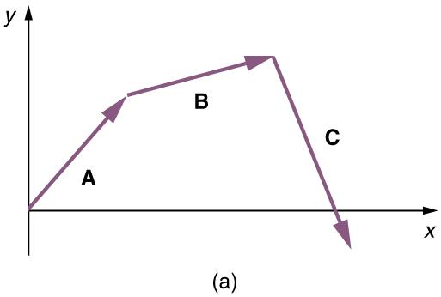
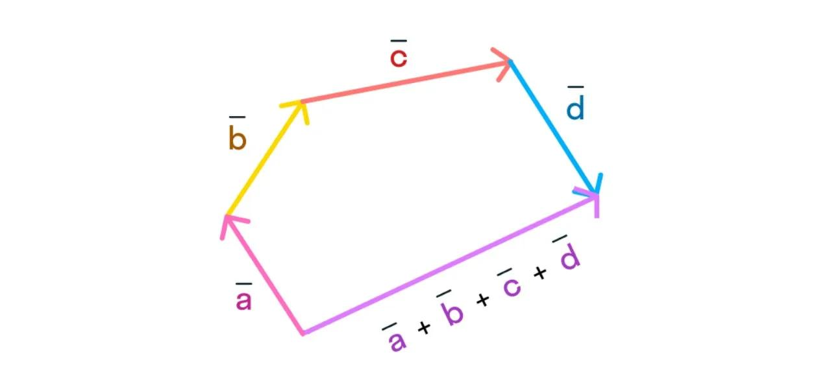

15. Time-Parameterized Piecewise Path
# Source: AI Source: Provided by: [Data Path: Persons Table -> ID Column: 1, Name_En Column: Motasem Essam] -> From: [ChatGPT] on [7/25/2026]
Definition
A Time-Parameterized Piecewise Path describes a moving point whose path changes according to different time intervals.
For example:
$$P\left(t\right)=\left\{\begin{matrix}\left(2 , t0\right), & 0≤t≤5, \\ \left(10 , 2\left(t-5\right)\right), & 5<t≤10.\end{matrix}\right.$$
Interpretation
During the first interval:
$$\text{horizontal motion}$$
During the second:
$$\text{vertical motion}.$$
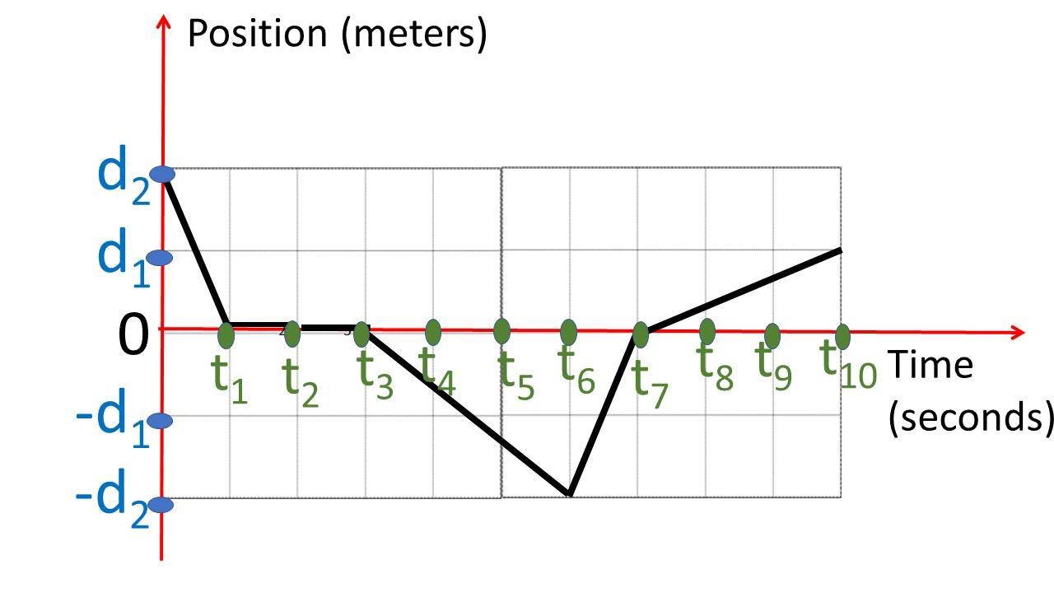
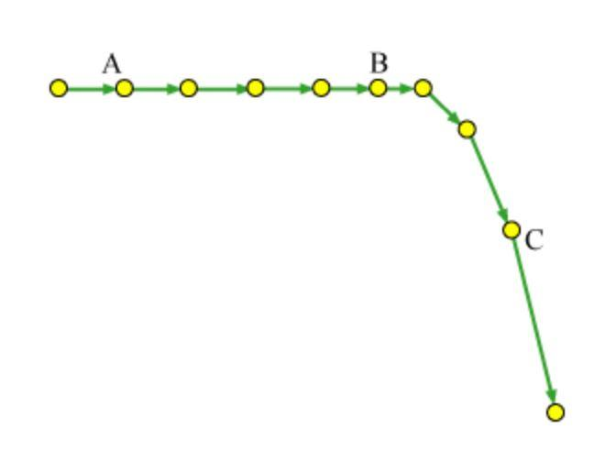
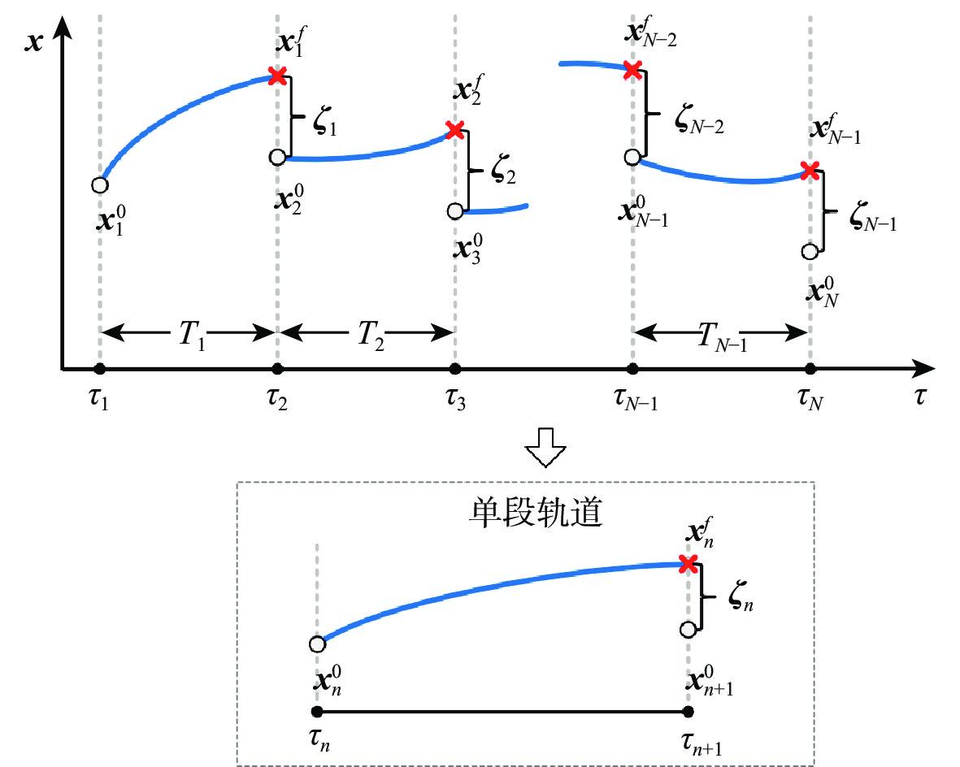
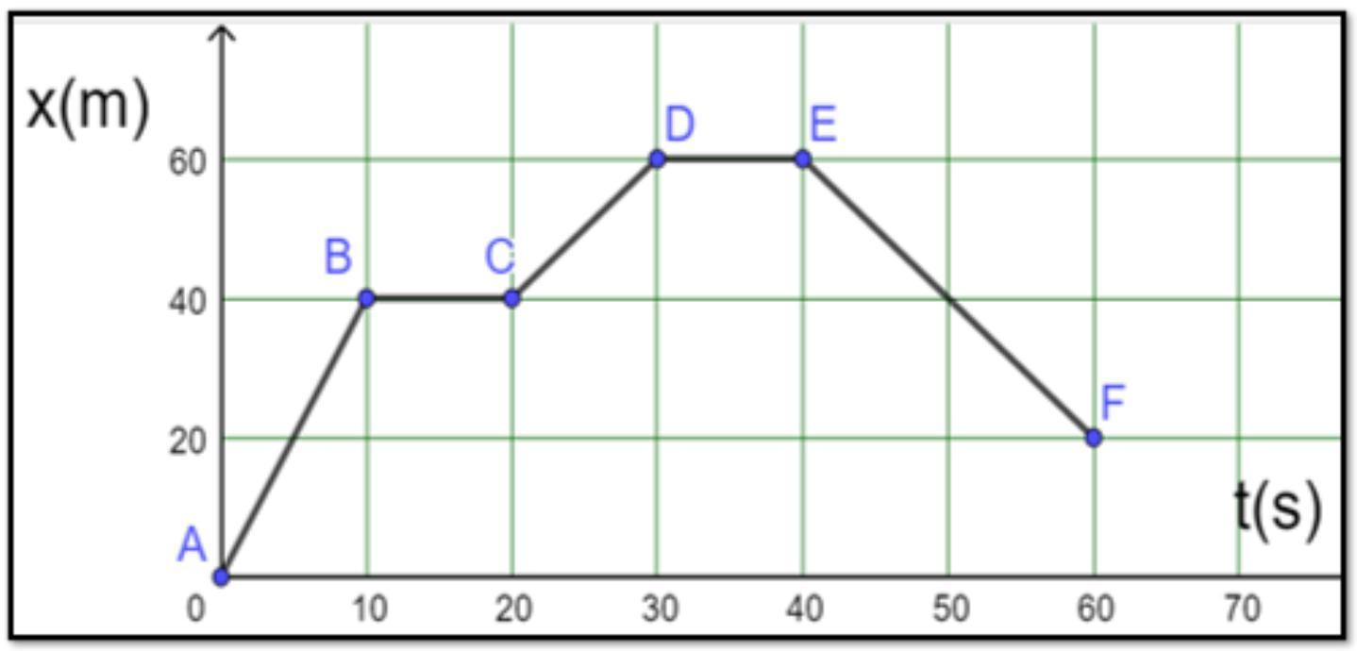
Important
A geometric path describes where the point moves.
A time-parameterized path additionally describes when it reaches each position.

16. Restricted Piecewise Path
# Source: AI Source: Provided by: [Data Path: Persons Table -> ID Column: 1, Name_En Column: Motasem Essam] -> From: [ChatGPT] on [7/25/2026]
Definition
A Restricted Piecewise Path is a piecewise path subject to additional geometric restrictions.
Examples:
$$x≥0 \\ y≤5$$
or:
$$P\left(t\right)∈R$$
where $R$is a specified region.
Example
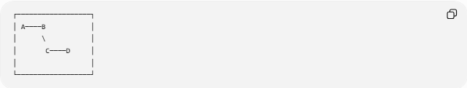
┌──────────────────┐
│ A────B │
│ \ │
│ C────D │
│ │
└──────────────────┘
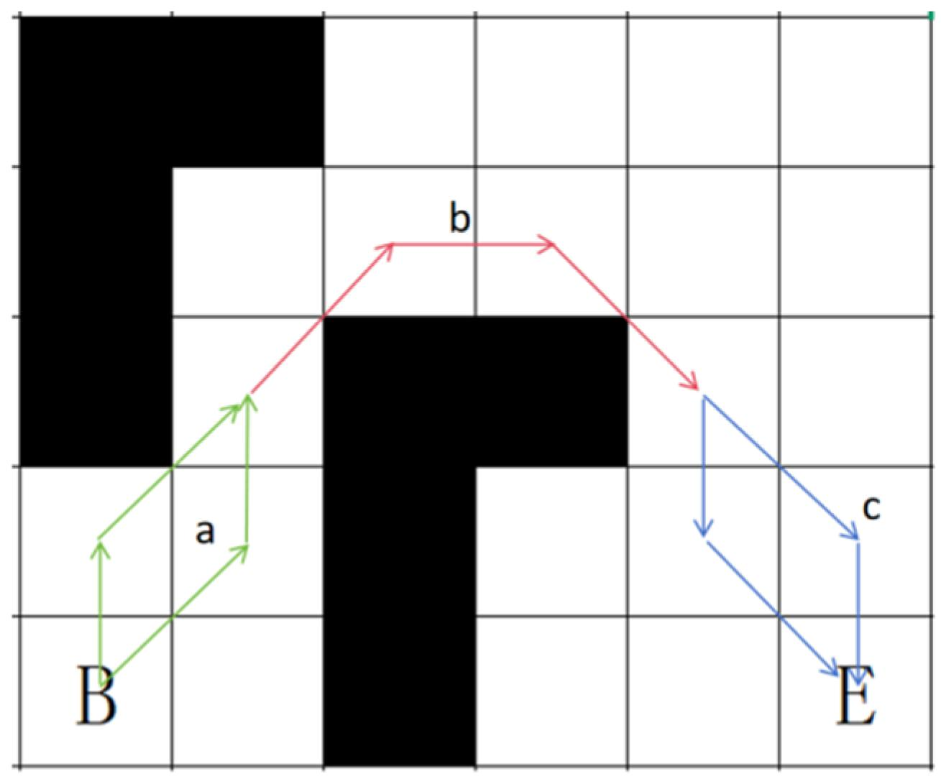
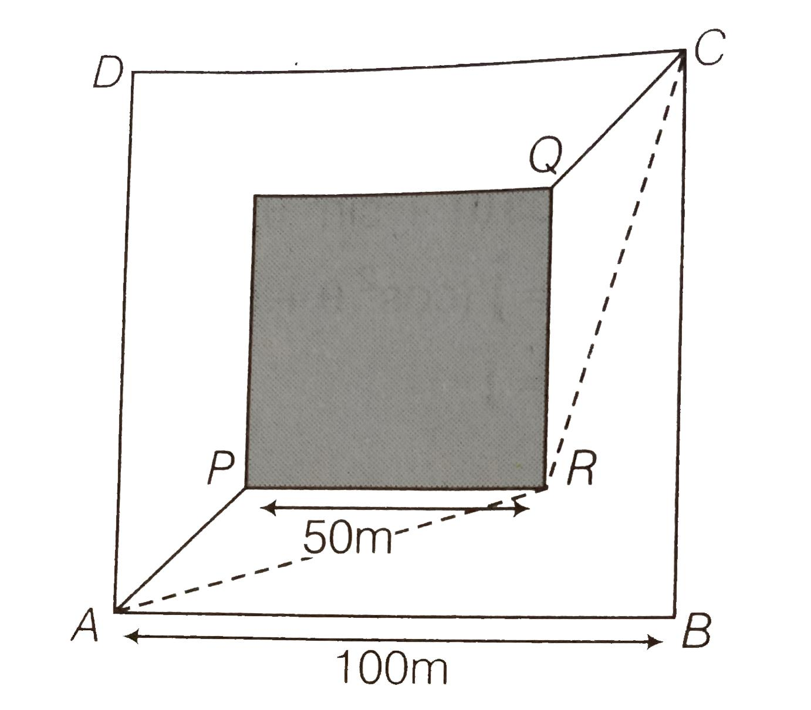
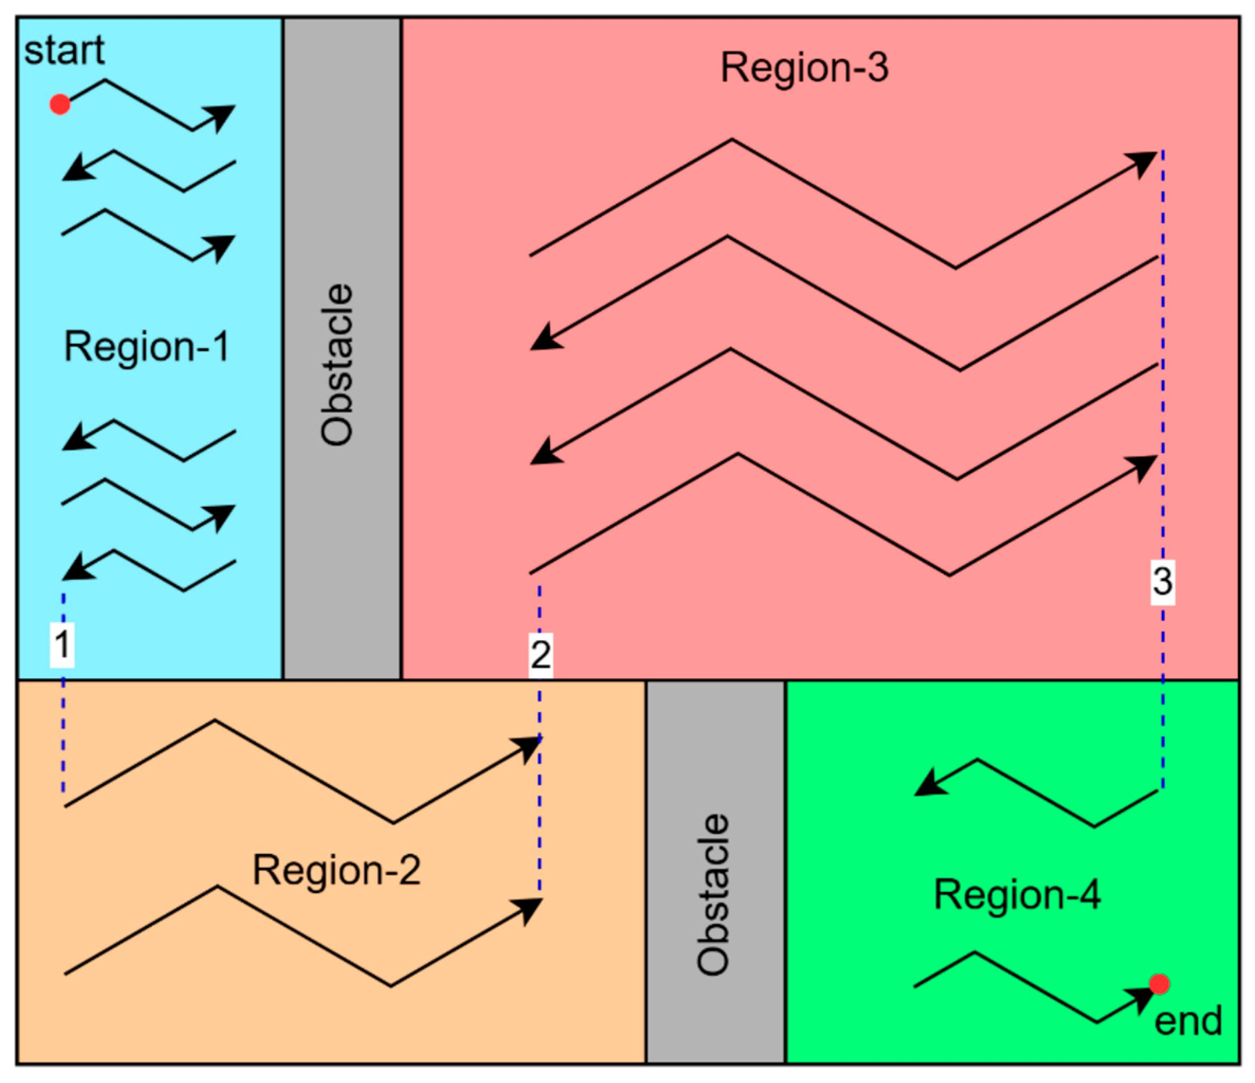
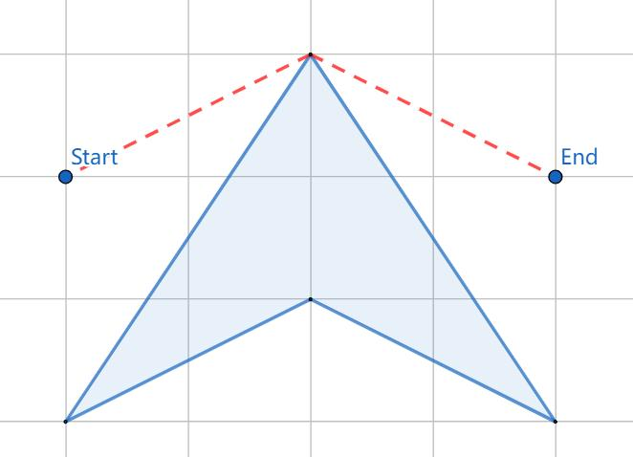
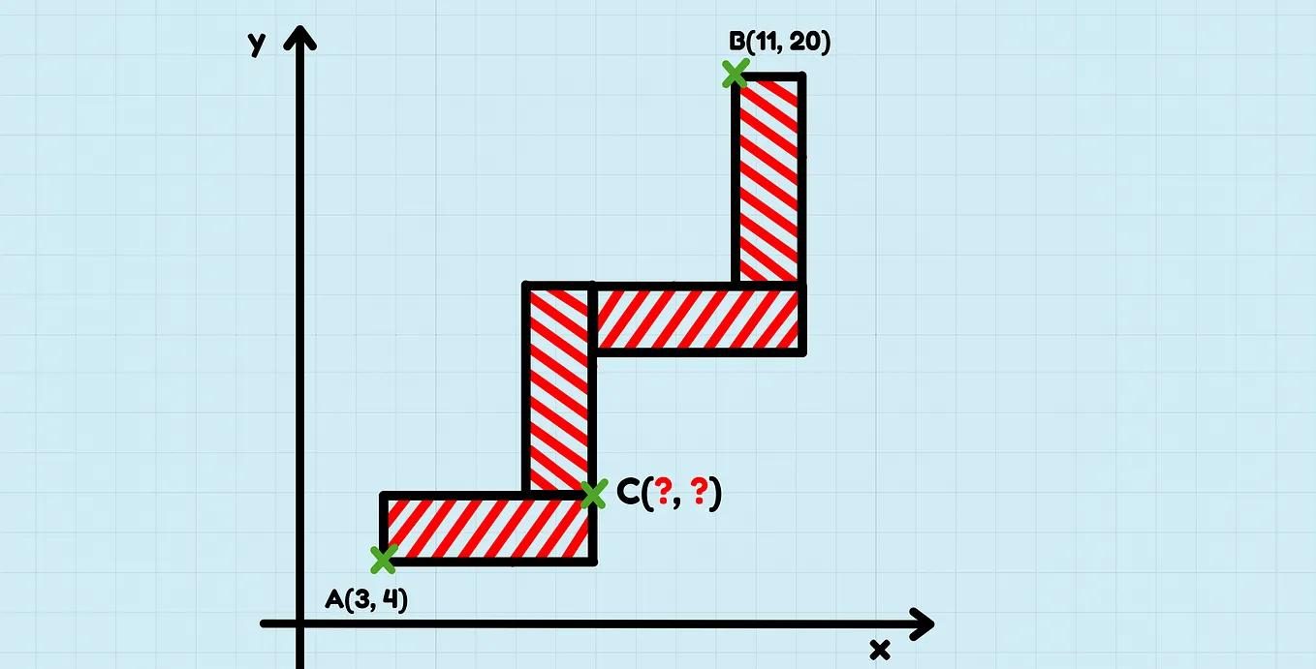
The path may be required to remain inside a specified region or avoid certain areas.

17. Monotone Piecewise Path
# Source: AI Source: Provided by: [Data Path: Persons Table -> ID Column: 1, Name_En Column: Motasem Essam] -> From: [ChatGPT] on [7/25/2026]
Definition
A Monotone Piecewise Path progresses consistently in a specified coordinate direction.
For example, an $x$-monotone path progresses from left to right without reversing its horizontal progression.
Example
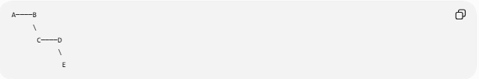
A────B
\
C────D
\
E
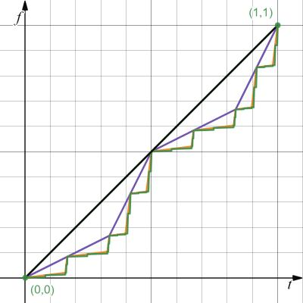
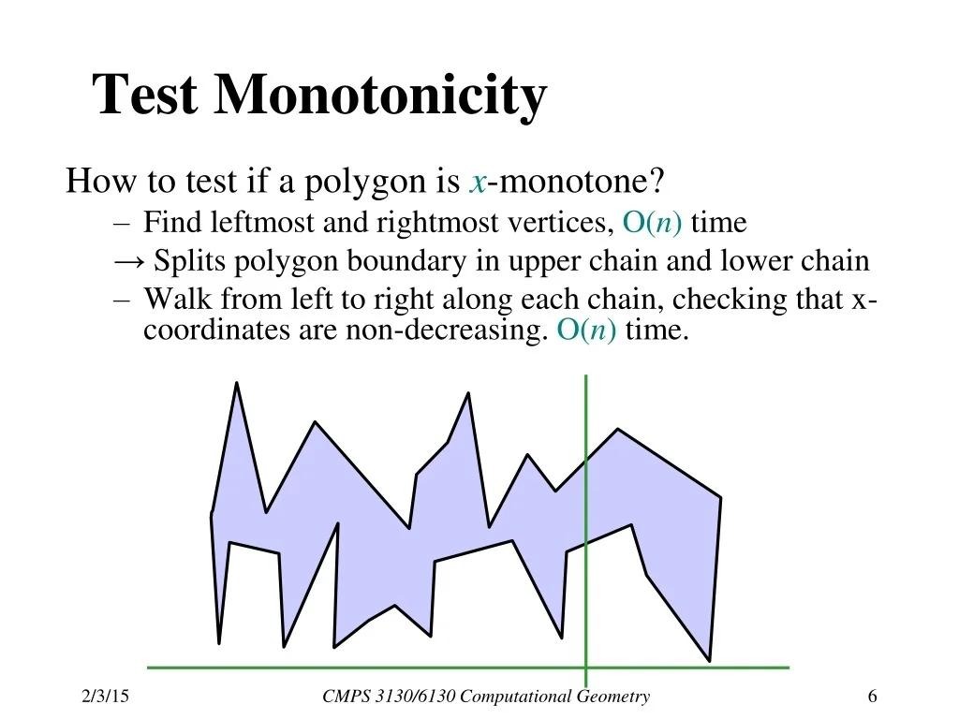
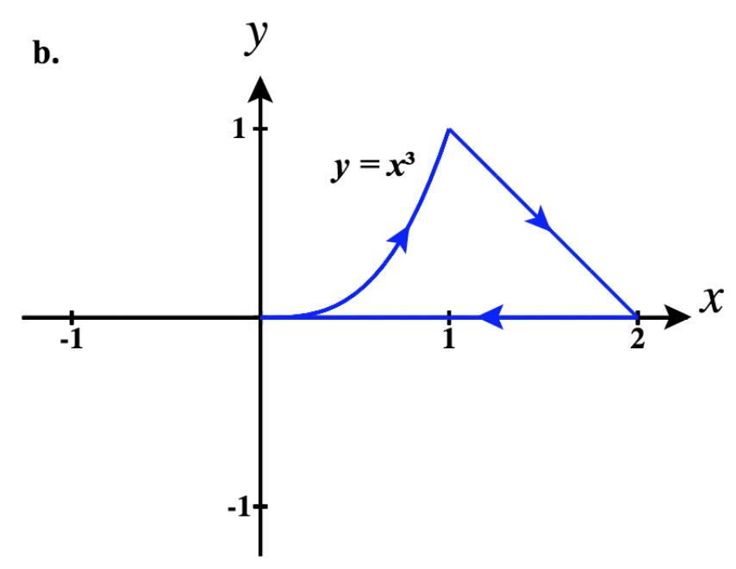
Applications
Monotone paths are important in:
- computational geometry
- polygon decomposition
- visibility problems
- path planning.

18. Piecewise-Polygonal Path
# Source: AI Source: Provided by: [Data Path: Persons Table -> ID Column: 1, Name_En Column: Motasem Essam] -> From: [ChatGPT] on [7/25/2026]
Definition
A Piecewise-Polygonal Path consists of polygonal subpaths that are joined together.
Each subpath may itself contain several straight segments.
Example
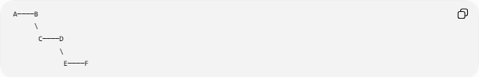
A────B
\
C────D
\
E────F
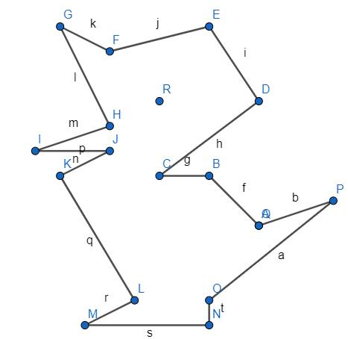
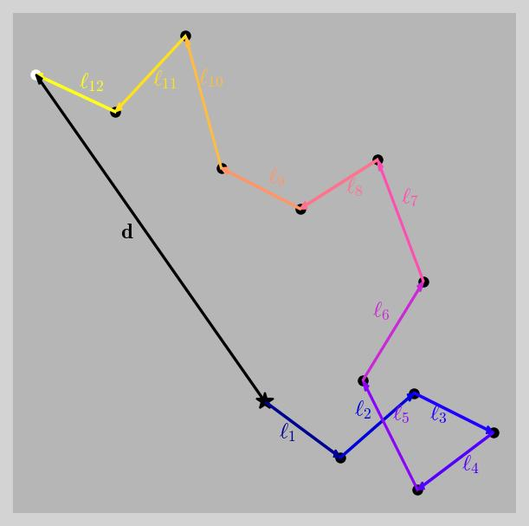
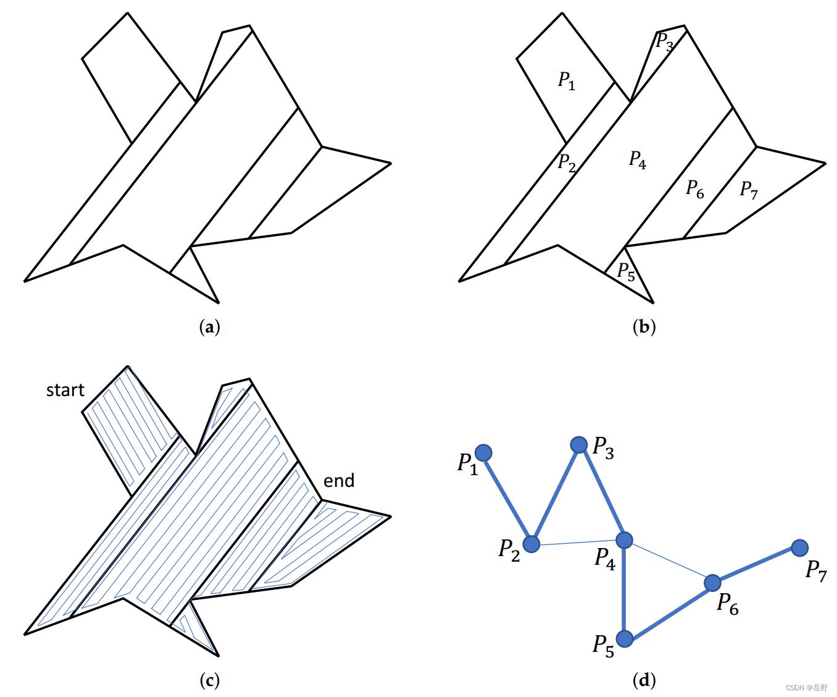
Important
Because a polygonal path is already piecewise-linear, this category is mainly useful when dividing a larger path into polygonal sections.

19. Piecewise Circular-Linear Path
# Source: AI Source: Provided by: [Data Path: Persons Table -> ID Column: 1, Name_En Column: Motasem Essam] -> From: [ChatGPT] on [7/25/2026]
Definition
A Piecewise Circular-Linear Path combines straight segments and circular arcs.
A common structure is:
$$\boxed{\text{Line}→\text{Circular Arc}→\text{Line}}$$
Example
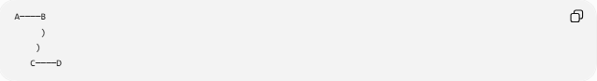
A────B
)
)
C────D
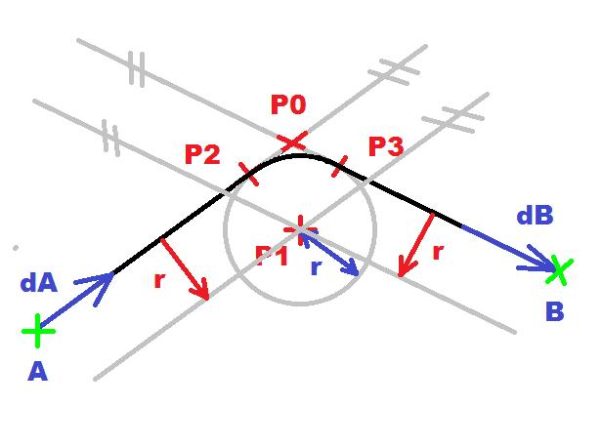
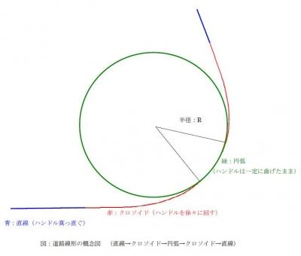
Applications
This type is particularly useful for modeling:
- roads
- railway tracks
- robot trajectories
- vehicle paths
- engineering designs.

20. Combined Piecewise Path
# Source: AI Source: Provided by: [Data Path: Persons Table -> ID Column: 1, Name_En Column: Motasem Essam] -> From: [ChatGPT] on [7/25/2026]
Definition
A Combined Piecewise Path contains several different types of geometric pieces in one complete path.
For example:
$$\boxed{\text{Straight}→\text{Circular Arc}→\text{Parabolic Arc}→\text{Straight}}$$
Example
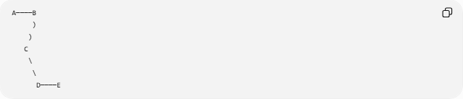
A────B
)
)
C
\
\
D────E
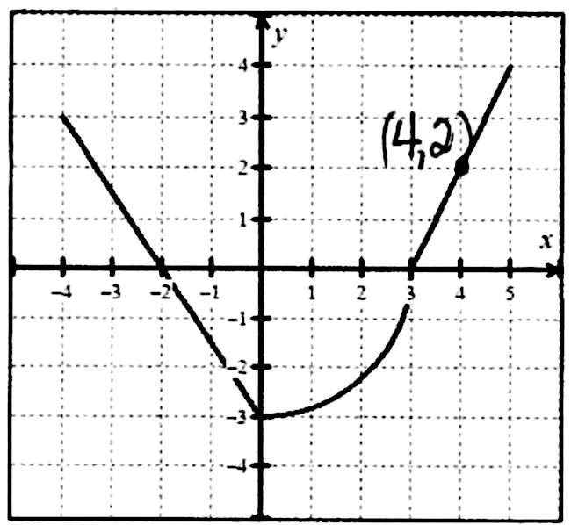
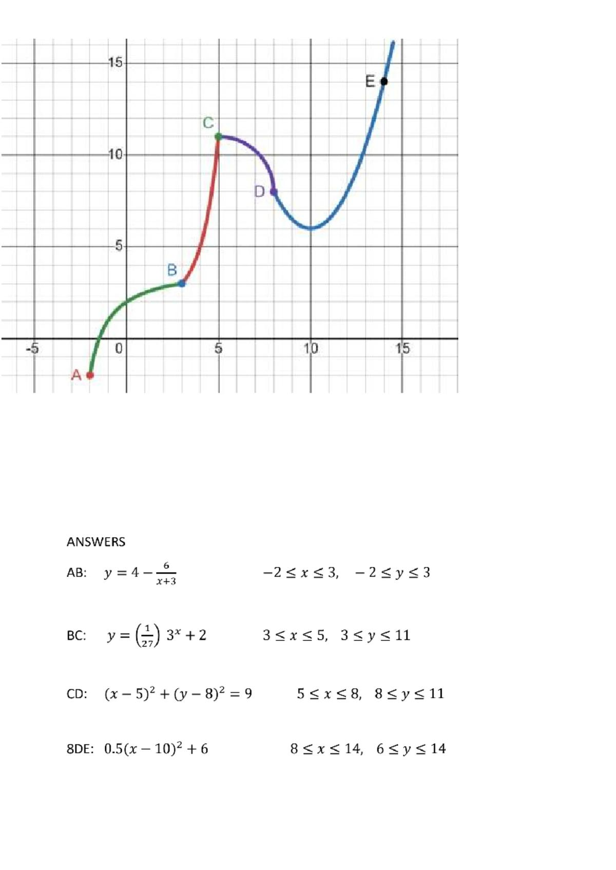
Each portion can have its own equation and geometric properties.

Mathematical Representation
# Source: AI Source: Provided by: [Data Path: Persons Table -> ID Column: 1, Name_En Column: Motasem Essam] -> From: [ChatGPT] on [7/25/2026]
A general piecewise path can be represented by:
$$\boxed{P\left(t\right)=\left\{\begin{matrix}P_{1}\left(t\right), & t_{0}≤t≤t_{1}, \\ P_{2}\left(t\right), & t_{1}≤t≤t_{2}, \\ ⋮ & \\ P_{n}\left(t\right), & t_{n-1}≤t≤t_{n}.\end{matrix}\right.}$$
Each function $P_{i}\left(t\right)$describes one piece.
For example:
$$P_{1}\left(t\right)=\text{line} \\ P_{2}\left(t\right)=\text{circular arc} \\ P_{3}\left(t\right)=\text{line}.$$
Therefore:
$$\boxed{\text{Line}→\text{Circular Arc}→\text{Line}}$$
is a piecewise path.

Connection Conditions
# Source: AI Source: Provided by: [Data Path: Persons Table -> ID Column: 1, Name_En Column: Motasem Essam] -> From: [ChatGPT] on [7/25/2026]
For a piecewise path to be connected, consecutive pieces must share a transition point.
If $P_{i}$ends at $V_{i}$and $P_{i+1}$begins at $V_{i}$:
$$\boxed{P_{i}∩P_{i+1}=\left\{V_{i}\right\}}$$
for a simple single-point connection.
For a continuous path:
$$\boxed{P_{i}\left(t_{i}\right)=P_{i+1}\left(t_{i}\right)}$$
at the transition.

Continuity vs Smoothness
# Source: AI Source: Provided by: [Data Path: Persons Table -> ID Column: 1, Name_En Column: Motasem Essam] -> From: [ChatGPT] on [7/25/2026]
These two concepts must be distinguished.
Continuous
The pieces meet:
$$\boxed{P_{i}∩P_{i+1}≠∅}$$
Smooth
The pieces meet and their tangent directions agree:
$$\boxed{T_{i}=T_{i+1}}$$
Conceptually:
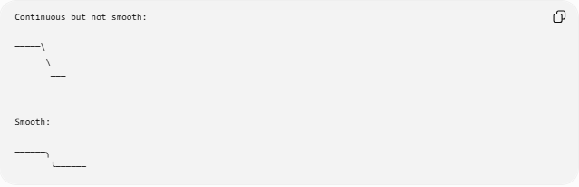
Continuous but not smooth:

─────\
\
───

Smooth:

──────╮
╰──────
Therefore:
$$\boxed{\text{Smooth}⇒\text{Continuous}}$$
but:
$$\boxed{\text{Continuous}⇏\text{Smooth}}$$

Total Length of a Piecewise Path
# Source: AI Source: Provided by: [Data Path: Persons Table -> ID Column: 1, Name_En Column: Motasem Essam] -> From: [ChatGPT] on [7/25/2026]
If the path contains $n$pieces:
$$P_{1},P_{2},…,P_{n},$$
then:
$$\boxed{L=L_{1}+L_{2}+⋯+L_{n}}$$
Example
Suppose:
- first straight piece = $5$
- circular arc = $4$
- second straight piece = $7$
Then:
$$L=5+4+7 \\ \boxed{L=16}$$

Piecewise Path and Locus
# Source: AI Source: Provided by: [Data Path: Persons Table -> ID Column: 1, Name_En Column: Motasem Essam] -> From: [ChatGPT] on [7/25/2026]
A locus describes a set of points satisfying a geometric condition.
A piecewise path describes a path constructed from multiple pieces.
For example:
$$P_{1}=\text{line segment}$$
and:
$$P_{2}=\text{circular arc}.$$
Then:
$$\boxed{P=P_{1}∪P_{2}}$$
forms a piecewise path.
The individual pieces can themselves be loci.

Piecewise Path vs Polygonal Path
# Source: AI Source: Provided by: [Data Path: Persons Table -> ID Column: 1, Name_En Column: Motasem Essam] -> From: [ChatGPT] on [7/25/2026]
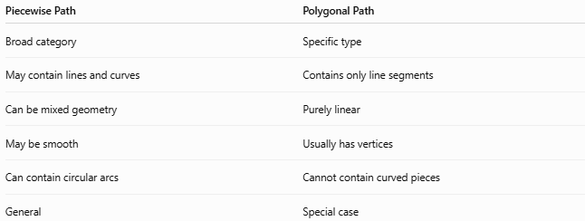
Piecewise Path | Polygonal Path
Broad category | Specific type
May contain lines and curves | Contains only line segments
Can be mixed geometry | Purely linear
May be smooth | Usually has vertices
Can contain circular arcs | Cannot contain curved pieces
General | Special case
Therefore:
$$\boxed{\text{Polygonal Path}⊂\text{Piecewise Path}}$$
and:
$$\boxed{\text{Polygonal Path}≈\text{Piecewise-Linear Path}}$$

Piecewise Path vs Straight-Line Path
# Source: AI Source: Provided by: [Data Path: Persons Table -> ID Column: 1, Name_En Column: Motasem Essam] -> From: [ChatGPT] on [7/25/2026]
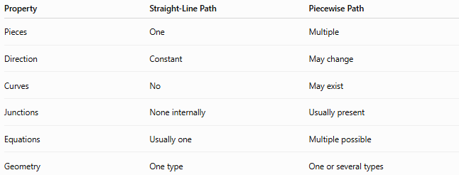
Property | Straight-Line Path | Piecewise Path
Pieces | One | Multiple
Direction | Constant | May change
Curves | No | May exist
Junctions | None internally | Usually present
Equations | Usually one | Multiple possible
Geometry | One type | One or several types

Piecewise Path vs Circular Path
# Source: AI Source: Provided by: [Data Path: Persons Table -> ID Column: 1, Name_En Column: Motasem Essam] -> From: [ChatGPT] on [7/25/2026]
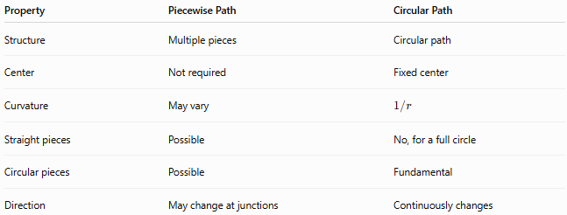
Property | Piecewise Path | Circular Path
Structure | Multiple pieces | Circular path
Center | Not required | Fixed center
Curvature | May vary | $$1/r$$
Straight pieces | Possible | No, for a full circle
Circular pieces | Possible | Fundamental
Direction | May change at junctions | Continuously changes

Applications of Piecewise Paths
# Source: AI Source: Provided by: [Data Path: Persons Table -> ID Column: 1, Name_En Column: Motasem Essam] -> From: [ChatGPT] on [7/25/2026]
Piecewise paths are useful whenever a complete path changes geometric behavior.
Geometry
A complex geometric construction can be represented as several simpler path pieces.
Computer Graphics
Objects and curves can be modeled from multiple segments.
Robotics
A robot may travel:
$$\text{Straight}→\text{Turn}→\text{Straight}.$$
Transportation
Roads and railway tracks often combine:
$$\text{Straight Segments}+\text{Circular Curves}.$$
Computational Geometry
Piecewise paths are fundamental in:
- shortest-path algorithms
- polygonal chains
- visibility problems
- collision detection
- path planning.

Classification Summary
# Source: AI Source: Provided by: [Data Path: Persons Table -> ID Column: 1, Name_En Column: Motasem Essam] -> From: [ChatGPT] on [7/25/2026]
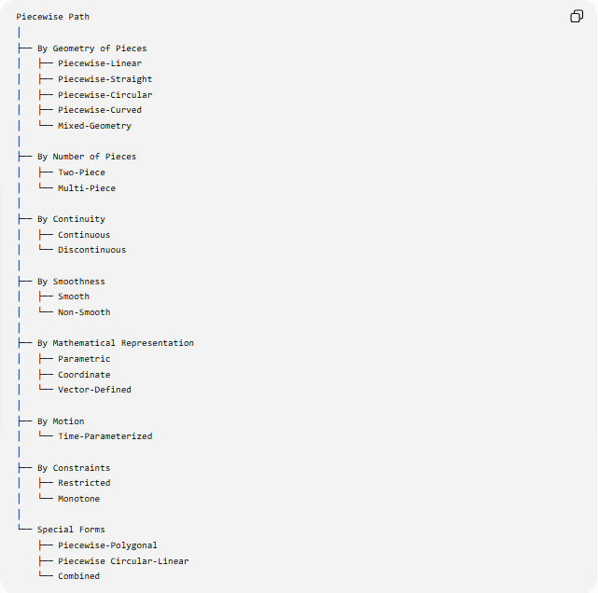
Piecewise Path
│
├── By Geometry of Pieces
│ ├── Piecewise-Linear
│ ├── Piecewise-Straight
│ ├── Piecewise-Circular
│ ├── Piecewise-Curved
│ └── Mixed-Geometry
│
├── By Number of Pieces
│ ├── Two-Piece
│ └── Multi-Piece
│
├── By Continuity
│ ├── Continuous
│ └── Discontinuous
│
├── By Smoothness
│ ├── Smooth
│ └── Non-Smooth
│
├── By Mathematical Representation
│ ├── Parametric
│ ├── Coordinate
│ └── Vector-Defined
│
├── By Motion
│ └── Time-Parameterized
│
├── By Constraints
│ ├── Restricted
│ └── Monotone
│
└── Special Forms
├── Piecewise-Polygonal
├── Piecewise Circular-Linear
└── Combined

Key Formulas
# Source: AI Source: Provided by: [Data Path: Persons Table -> ID Column: 1, Name_En Column: Motasem Essam] -> From: [ChatGPT] on [7/25/2026]
General Piecewise Path
$$\boxed{P=\bigcup_{i=1}^{n}{P_{i}}}$$
Connected Pieces
$$\boxed{P_{i}∩P_{i+1}=\left\{V_{i}\right\}}$$
for a single-point connection.
Total Length
$$\boxed{L=\sum_{i=1}^{n}{L_{i}}}$$
Straight-Line Piece
$$\boxed{r\left(t\right)=A+t\left(B-A\right)}$$
where:
$$0≤t≤1.$$
Circular Piece
$$\boxed{x=h+r\cos{t}} \\ \boxed{y=k+r\sin{t}}$$
Continuity
$$\boxed{P_{i}\left(t_{i}\right)=P_{i+1}\left(t_{i}\right)}$$
Smoothness
$$\boxed{T_{i}\left(V_{i}\right)=T_{i+1}\left(V_{i}\right)}$$

Key Points
# Source: AI Source: Provided by: [Data Path: Persons Table -> ID Column: 1, Name_En Column: Motasem Essam] -> From: [ChatGPT] on [7/25/2026]
- A Piecewise Path consists of multiple path pieces.
- Each piece may follow a different geometric rule.
- Pieces can be straight, circular, curved, or mixed.
- A Piecewise-Linear Path consists entirely of straight-line pieces.
- A Polygonal Path is essentially a piecewise-linear path.
- A path can contain two pieces or many pieces.
- Pieces may be continuous or discontinuous.
- A continuous path can still have sharp corners.
- A smooth path has matching tangent directions at its junctions.
- Piecewise paths can be described using coordinate, parametric, and vector equations.
- A time-parameterized piecewise path describes both position and time.
- Restrictions can limit where the path is allowed to travel.
- The total length equals the sum of the lengths of its individual pieces.
- Piecewise paths can combine fundamentally different geometric forms.

Conclusion
# Source: AI Source: Provided by: [Data Path: Persons Table -> ID Column: 1, Name_En Column: Motasem Essam] -> From: [ChatGPT] on [7/25/2026]
A Piecewise Path is a general geometric path constructed from multiple individual pieces:
$$\boxed{P=P_{1}∪P_{2}∪⋯∪P_{n}}$$
The pieces can be straight segments, circular arcs, other curves, or combinations of these. Important classifications include Piecewise-Linear, Piecewise-Circular, Piecewise-Curved, Mixed-Geometry, Continuous, Smooth, Parametric, Coordinate, Vector-Defined, Restricted, and Time-Parameterized Paths.
The fundamental idea is:
$$\boxed{\text{Complete Path}=\text{Multiple Geometric Pieces}}$$
This makes Piecewise Paths an important generalization of Straight-Line Paths, Polygonal Paths, and Circular Paths, and an important foundation for geometric modeling, coordinate geometry, computational geometry, motion trajectories, robotics, transportation design, and path planning.

